INFORMATION GUIDE



Temora Shire Council

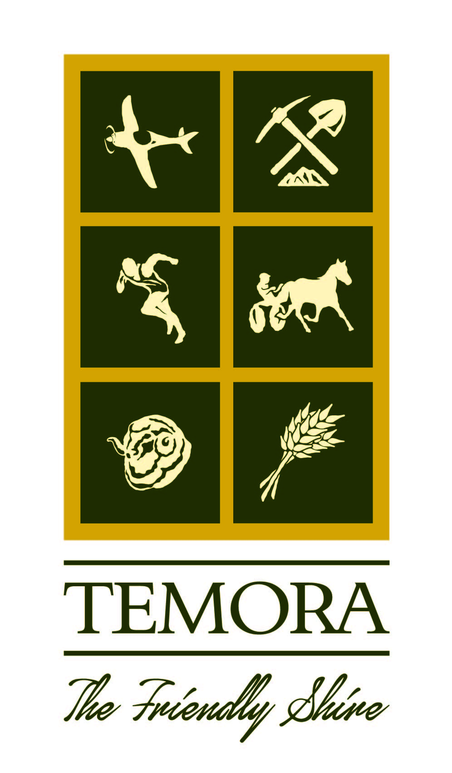
105 Loftus Street
TEMORA NSW 2666
Phone: (02) 6980 1100
Fax: (02) 6980 1138
Email: temshire@temora.nsw.gov.au
Web: www.temora.nsw.gov.au

Contents
Vision, Mission And Values 4
Our Vision 4
Our Mission 4
Our Core Values 4
Organisational Structure And Resources 5
Functions Of Temora Shire Council 8
Service Functions 8
Regulatory Functions 8
Ancillary Functions 8
Revenue Functions 8
Administrative Functions 9
Enforcement Functions 9
Functions Confered Under Other Acts 9
Community Participation In Council’s Policy Formation And The Exercise Of Functions 10
Representation 10
Personal Participation 10
Community Consultation 10
Information Held By Temora Shire Council 11
Files 11
Policy Information 11
General Information 11
How Do The Public Access Information Under The Gipa Act? 11
Open Access Information 12
Information About Council 12
Plans And Policies 12
Information About Development Applications 13
Approvals, Orders And Other Documents 13
What Information Is Council Not Allowed To Release? 13
Proactive Release 14
Informal Release 14
Formal Access 14
Fees And Charges 15
Interaction With Copyright Legislation 16
Interaction With Privacy Legislation 16
Public Interest Test 16
Access To Council Information 17
Public Officer And Right To Information Officer 17
Open Data 18
The Information & Privacy Commissioner 18

This Information Guide is a mandatory requirement under Section 20 of the Government
Information (Public Access) Act 2009 (GIPA Act). The Act requires Council to produce an Information Guide within six months of the commencement of the Act, being 1 July 2010, with a view to amending and adopting the Information Guide at intervals of not more than 12 months.

The Information Guide describes the structure and functions of Council and how these affect the community; specifies ways the community can participate in decision making and provides information about the various kinds of information Council holds and how the public can access the information.

VISION, MISSION AND VALUES

OUR VISION

Our community strives to reflect the qualities of its greatest asset – its people, each of whom we value as individuals.
With our rural heritage as our foundation, we embrace change and grasp every opportunity to enhance our environment, economy and lifestyle.

OUR MISSION

To achieve the best possible outcomes for our community by striving for excellence in all we do.

OUR CORE VALUES

We will make the best decisions we can through:
- Leadership and Respect – we will act decisively with knowledge and courage in the best interest of all our community
- Integrity and Transparency – we will act honestly and openly in all our dealings with a view to making ethical and equitable decisions

We will always act with the community as our primary consideration through:
- Community Focus – we will engage with our community to provide services that respond to community need
- Future Custodianship – we will always act with consideration of the impact of our actions on future generations

We will value the views and input of others through:
- Teamwork and Cooperation – we will work together with open communication to achieve a common goal by sharing knowledge and supporting each other
- Effective Partnerships – we will treat everyone with respect by being inclusive, non-judgmental and valuing diversity

We will maximise our opportunities through:
- Innovation – we will encourage creative thinking and innovation based on detailed knowledge and accept that bold actions carry a degree of risk
- Continuous Improvement – we will always strive to achieve our goals more efficiently through improvements in process or new technology

ORGANISATIONAL STRUCTURE AND RESOURCES
The Temora Shire Council is constituted under the NSW Local Government Act 1993. The leadership of Temora Shire Council is provided under nine Councillors, one of whom is the Mayor, who are elected by the residents and ratepayers of the Shire. Councillor elections are held every four years, the current Councillors were elected in December 2021. The Mayor is elected bi-annually in a ballot by fellow Councillors, which was conducted on 13 January 2022. Councillor Rick Firman was elected Mayor.

The Role of the Mayor is to:

- to be the leader of the council and a leader in the local community
- to advance community cohesion and promote civic awareness
- to be the principal member and spokesperson of the governing body, including representing the views of the council as to its local priorities
- to exercise, in cases of necessity, the policy-making functions of the governing body of the council between meetings of the council
- to preside at meetings of the council
- to ensure that meetings of the council are conducted efficiently, effectively and in accordance with this Act
- to ensure the timely development and adoption of the strategic plans, programs and policies of the council
- to promote the effective and consistent implementation of the strategic plans, programs and policies of the council
- to promote partnerships between the council and key stakeholders
- to advise, consult with and provide strategic direction to the general manager in relation to the implementation of the strategic plans and policies of the council
- in conjunction with the general manager, to ensure adequate opportunities and mechanisms for engagement between the council and the local community
- to carry out the civic and ceremonial functions of the mayoral office
- to represent the council on regional organisations and at inter-governmental forums at regional, State and Commonwealth level
- in consultation with the Councillors, to lead performance appraisals of the general manager
- to exercise any other functions of the council that the council determines

The role of a Councillor, as an elected person:

- A Councillor is accountable to the local community for the performance of the council

The Chief Executive Officer of Council is the General Manager. The General Manager is responsible for the efficient and effective operation of Council’s organisation and for ensuring the implementation, without undue delay, of decisions of Council.

The role of The General Manager:

- to conduct the day-to-day management of the council in accordance with the strategic plans, programs, strategies and policies of the council
- to implement, without undue delay, lawful decisions of the Council
- to advise the Mayor and the governing body on the development and implementation of the strategic plans, programs, strategies and policies of the council
- to advise the Mayor and the governing body on the appropriate form of community consultation on the strategic plans, programs, strategies and policies of Council and other matters related to Council
- to prepare, in consultation with the mayor and the governing body, the Council’s community strategic plan, community engagement strategy, resourcing strategy, delivery program, operational plan and annual report
- to ensure that the mayor and other Councillors are given timely information and advice and the administrative and professional support necessary to effectively discharge their functions
- to exercise any of the functions of the Council that is delegated by the Council to the General Manager
- to appoint staff in accordance with the organisation structure determined under this Chapter and the resources approved by the council
- to direct and dismiss staff
- to implement the council’s workforce management strategy
- any other functions that are conferred or imposed on the General Manager by or under this or any other Act.

To assist the General Manager in the exercise of these functions, there are three departments of Council. These departments are Administration & Finance, Engineering and Environmental. The Administration & Finance and Environmental departments are each headed by a Director. The Engineering department is headed by two Managers – the Engineering Asset Manager and Engineering Works Manager.
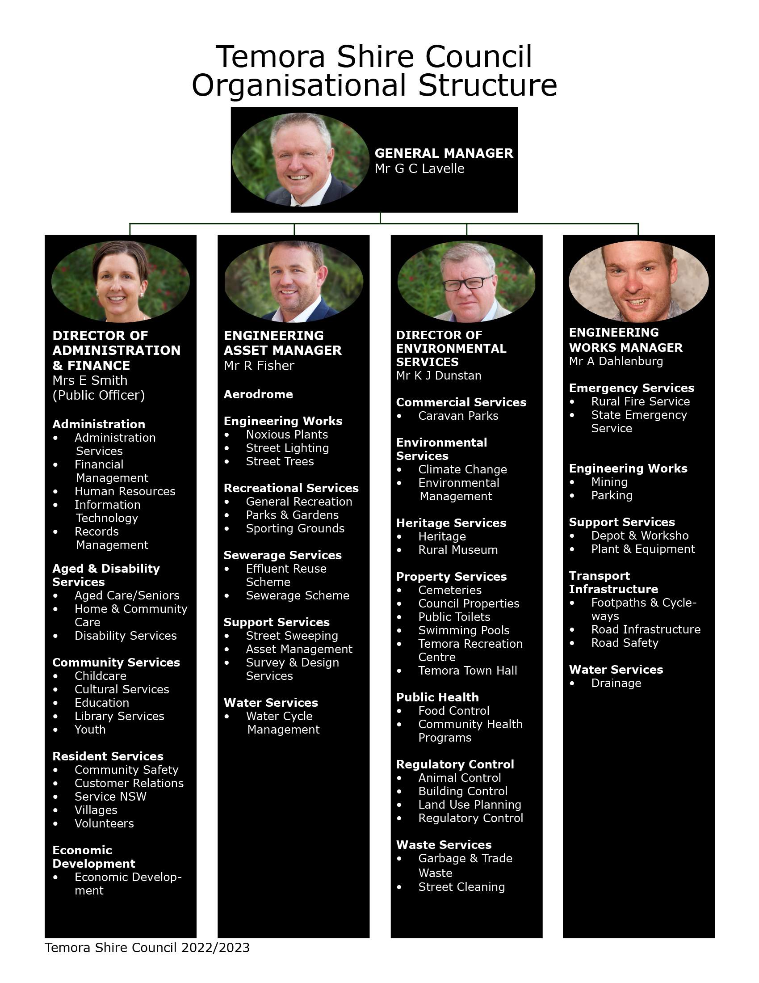

FUNCTIONS OF TEMORA SHIRE COUNCIL
The functions of Council are set out in the Local Government Act and fall into six categories. The following is an outline of the functions of Council and show how these functions impact the community.

SERVICE FUNCTIONS
• Provision of community health, recreation, education and information services
• Environmental protection, conservation and improvement services and facilities
• Waste removal and disposal
• Land and property, industry and tourism development and assistance
• Civil infrastructure planning
• Civil infrastructure maintenance and construction
• Cultural, educational and information services and facilities
• Sporting recreational and entertainment services and facilities
• Pest eradication and control services and facilities

The service functions of Council are a major way in which Council affects the community, as these functions are for the community. Some of the major services provided to the community are infrastructure, waste disposal, and sewerage, Council’s capital works program as identified in its Delivery Plan, tourism development and assistance, recreation facilities including swimming pools, libraries, footpaths, roads and street lighting.

REGULATORY FUNCTIONS
• Approvals
• Orders
• Building certificates

The regulatory functions of Council ensure that any development promotes community safety and minimises adverse effects on the social and physical environment. The regulatory functions place restrictions on developments and buildings to ensure that they meet certain requirements affecting the amenity of the community and not endanger the lives and safety of any person.

ANCILLARY FUNCTIONS
• Resumption of land
• Powers of entry and inspection

The ancillary functions of Council give support to and aid in the carrying out of, the other functions of Council, particularly our service and regulatory functions. This function will only affect a small number of members in our community and confers on Council the powers to enter land and buildings and to carry out inspections.

REVENUE FUNCTIONS
• Rates
• Charges
• Fees
• Borrowings
• Investments

The revenue functions of Council affect the public directly in that the revenue from rates and other charges paid by the public to Council is used by Council to fund the services and facilities provided to the community.

ADMINISTRATIVE FUNCTIONS
• Employment of staff
• Operational Plan, Delivery Plan & Resourcing Strategy
• Financial Reporting
• Annual Reports

The administrative functions of Council ensure the efficiency and effectiveness of Council.

Council has in place a number of plans, procedures and policies to ensure this. These plans, procedures and policies outline to the community what Council is doing and how it will achieve its objectives and the activities and expenditure of Council.

ENFORCEMENT FUNCTIONS
• Proceedings for breaches of the Local Government Act
• Prosecution of offences
• Recovery of rates and charges

The enforcement functions of Council will only affect those members of the community who are in breach of certain pieces of legislation. Temora Shire Council is committed to enforcing legislation to ensure that our community is happy and safe. We achieve this through fines and penalties.

FUNCTIONS CONFERED UNDER OTHER ACTS
While the main functions of Council are conferred under the Local Government Act, other Acts also confer functions for Council. These include:

Community Land Development Act 1989
Companion Animals Act 1998
Conveyancing Act 1919
Environmental Planning and Assessment Act 1979
Fire Brigades Act 1989
Fluoridation of Public Water Supplies Act 1957
Food Act 2003
Impounding Act 1993
Library Act 1939
Protection of the Environment Operations Act 1997
Public Health Act 1991
Recreation Vehicles Act 1983
Roads Act 1993
Rural Fires Act 1997
State Emergency Service Act 1989
Strata Schemes (Freehold Development) Act 1973
Strata Schemes (Leasehold Development) Act 1986
Swimming Pools Act 1992

COMMUNITY PARTICIPATION IN COUNCIL’S POLICY FORMATION AND THE EXERCISE OF FUNCTIONS
There are two broad ways in which the community can participate in the policy formation and the general activities of Council. These are through representation and personal participation.

REPRESENTATION
Local Government in Australia is based on the principle of representative democracy. This means that the people elect representatives to their Council to make decisions on their behalf. In New South Wales, local government Councillor elections are held every four years. The next elections are to be held in September 2024.

Members of the community are able to raise issues with, and make representations to, the elected Councillors. The Councillors, if they agree with the issue or representation, may pursue the matter on the resident’s behalf thus allowing members of the public to influence the development of policy. Councillors contact details are available on Council’s website.

PERSONAL PARTICIPATION
There are many avenues that members of the community are able to personally participate in the formation of Council policies and the functions of Council.

Council meetings are held on the third Thursday of each month, commencing at 4:00pm. All Council and Committee meetings are open to the public, except for confidential sessions. The agenda and reports for each meeting are available at Council’s Administration building, and on Council’s website.

Council has several committees which comprise or include members of the public. Committee meetings are held at various times. For details of Council committees and committee meeting times and locations, please refer to the individual committee meetings on Council’s website.

Members of the public, by prior arrangement, may address Council or committee meetings. Public participation in decision making is welcomed.

Council publishes content on our homepage under “News” and also under a “On Exhibition”.

COMMUNITY CONSULTATION
Temora Shire Council is committed to hearing the concerns and ideas of the community and working with the community to better enhance our Shire. In 2021 Council conducted community consultations to talk directly with members of the community on the direction and expectations from Council for the next 10 years. Community consultation provides interested residents with the opportunity to comment. From this consultation the Community Strategic Plan “Temora Tomorrow – Towards 2035” was developed. Council anticipates conducting further community consultations in 2024.

INFORMATION HELD BY TEMORA SHIRE COUNCIL
Council holds a wide range of information; this is in both hard copy and electronic form that relate to the functions undertaken by it. This information is contained in:

• Files (hard copy and electronic)
• Policy Information
• General Information

Council’s website holds a significant amount of this information in which the public can freely have access to and download. Some information held by Council will require a Formal Access Application under the GIPA Act. Information regarding this procedure is available on Council’s website at www.temora.nsw.gov.au/Your-Council/Access-to-information

FILES
Council has an electronic document management system. Council’s files are located within this system, except for development/building/construction applications, which are maintained in hard copy files.

Council’s hard copy files are not available on our website and files created prior to the implementation of Council’s electronic document management system will not be converted to electronic format. Information on these files may be made available either by informal release by filling in an Informal Access Application or via formal access by filling in a Formal Access Application, unless there is an overriding public interest against disclosure of the information, in accordance with the provisions of the GIPA Act. All of the information and access applications relating to this can be located on Council’s website under “Access to Information”.

POLICY INFORMATION
Council’s policies are available on Council’s website for the public to view and download. There are some internal Human Resources policies that are not available on our website, but are available upon request, free of charge in either electronic or hard copy format.

GENERAL INFORMATION
The Government Information (Public Access) Regulation (GIPA Regulation) requires that certain information held by Council, is to be made publicly available for inspection, free of charge. Where possible, Council has made this information available on our website. Alternatively, you may view information at Councils premises during office hours.

HOW DO THE PUBLIC ACCESS INFORMATION UNDER THE GIPA ACT?
The Act establishes four ways for the public to access government information:

• Mandatory Proactive Release
• Proactive Release
• Informal Release
• Formal Access Application

Open Access Information
Certain information must be made publicly available free of charge. Most Open Access Information is available on Council’s website.

Council publishes open access, or mandatory release information on its website unless there is an overriding public interest against disclosure or to do so would impose an unreasonable additional cost on Council. In respect of the latter, Council will make the information freely available in another format e.g., hard copy at the Council Administration Office.

The open access information is:

• Council’s policy Information
• An Information Guide with information about the Council’s structure and functions, and listing the type of information that is publicly available
• A disclosure log of formal access applications where in Council’s opinion the information released may be of interest to other members of the public
• A register of contracts worth more than $150,000 that Council has with private sector bodies
• A record of open access information that Council does not make publicly available on the basis of an overriding public interest against disclosure.

Schedule 1 of the GIPA Regulations also stipulates that the following additional documents are to be provided as open access information by council, divided into four sections – Information about Council, Plans and Policies, Information about DAs and Approvals, Orders and Other Documents.

Information about Council
• The model code of conduct prescribed under section 440(1) of the Local Government Act
• Council’s adopted Code of Conduct
• Code of Meeting Practice
• Annual Report
• Annual Financial Reports
• Auditor’s Report
• Operational Plan, Delivery Plan & Resourcing Strategy
• EEO Management Plan
• Policy concerning the Payment of Expenses and Provision of Facilities to the Mayor and Councillors
• Returns of the Interests of Councillors, Designated Persons and Delegates
• Agendas, Business Papers and Minutes of Council/Committee meetings (except meetings that are closed to the public)
• Land Register
• Register of Investments
• Register of Delegations
• Register of current Declarations of Disclosures of Political donations
• Register of Voting on Planning Matters.

Plans and Policies
• Local Policies adopted by Council concerning approvals and orders
• Plans of Management for Community Land
• Environmental Planning Instruments, Development Control Plans

Information about Development Applications
- Development Applications and any associated Information received in relation to a proposed development including:
- Home Warranty Insurance Information
- Construction Certificates
- Occupation Certificates
- Structural Certification Information
- Town Planner Reports
- Submissions received on Development Applications
- Heritage Consultant Reports
- Tree Inspections Consultant Reports
- Acoustic Consultant Reports
- Land Contamination Consultant Reports
- Records of decisions on Development Applications including decisions on appeals
- Records describing the general nature of information that Council decides to exclude from public view after application of public interest test considerations.
- The above does not apply to so much of the information referred to above as consists of:
- The plans and specifications for any residential part of a proposed building, other than plans that merely show its height and its external configuration in relation to the site on which it is proposed to be erected or
- Commercial information, if the information would likely prejudice the commercial position of the person who supplied it or to reveal a trade secret.
- Development applications made before 1 July 2010 and any associated documents received (whether before, on or after that date) in relation to the application.

Approvals, Orders and Other Documents
• Applications or approvals under part 1 of Chapter 7 of the Local Government Act 1993
• Applications for approvals under any other Act and any associated Information received
• Records of approvals granted or refused, any variation from Council Policies with reasons for the variation, and decisions made on appeals concerning approvals
• Orders given under Part 2 of Chapter 7 of the Local Government Act 1993, and any reasons given under section 136 of the Local Government Act 1993
• Orders given under the Authority of any other Act
• Records of Building Certificates under the Environmental Planning and Assessment Act 1979
• Plans of land proposed to be compulsorily acquired by Council
• Compulsory Acquisition Notices
• Leases and Licenses for use of Public Land classified as Community Land.
Copies of Information provided are given for information purposes only and are provided by Council to meet its requirements under relevant legislation.

For more information on how to access information and about the GIPA Act, please refer to Council’s website under Your Council / Access to Information.

What Information is Council not allowed to release?
Council may refuse a request for information if there is an overriding public interest against disclosure or if searching for the requested information would require unreasonable and substantial diversion of the Council’s resources.

For more detail on information for which there is a conclusive presumption of overriding public interest against disclosure, please refer to Schedule 1 of the GIPA Act.

Council will always explain to the applicant its reasons for not releasing the information. Where there is an overriding public interest against disclosure, any remaining information contained within the requested document will be available under the Act.

Proactive Release
In addition to Open Access Information, Council will make as much other information as possible publicly available, unless there is an overriding public interest against disclosure. Such information may include frequently requested information or information of public interest that has been released as a result of other requests. As part of its proactive release strategy, Council maintains a register of all Information Requests for Information received to readily identify the type of information frequently requested with the view of making such information publicly available on its website, subject to Copyright and Privacy provisions as outlined later in this document and application of the Public Interest Test also outlined below.

Members of the public are encouraged to contact Council with suggestions for information which can be considered for authorised proactive release.

Informal Release
Access to information which is not available as Mandatory Public Release (open access) or Proactive Release may be provided through Informal Release. Council generally releases other information in response to an informal request subject to any reasonable conditions as Council thinks fit to impose.
Council is authorised to release information unless there is a public interest against disclosure. To enable the release of as much information as possible, Council is also authorised to redact content from a copy of information to be released, if the inclusion of the redacted information would otherwise result in an overriding public interest against disclosure.

Application should be made to Council by submitting an Informal Request for Information application form, available on Council’s website https://www.temora.nsw.gov.au/Your-Council/Access-to-information/How-Do-I-Make-an-Informal-Access-Application or by contacting Council on 02 6980 1100.

Under informal release, Council has the right to decide by what means information is to be released.

Formal Access
Prior to lodging a Formal Access Application, a person seeking information from Council should check if the information being sought is already available on Council’s website or could easily be made available through an informal request application.

If information:
- is not available via Proactive or Informal Release; or
- involves a large volume of information, requires extensive research and accordingly will involve an unreasonable amount of time and resources to produce; or
- contains personal or confidential information about a third party which may require consultation; or
- is of a sensitive nature that requires careful weighting of the consideration in favour of and against disclosure, then
Council requires a Formal Access Application to be submitted.

Please note, an application will be invalid if it seeks access to excluded information of Council or does not meet the requirements for a Formal Access application.

A Formal Access application must:
- be in writing
- specify it is made under the GIPA Act
- state an Australian postal address
- be accompanied by the $30.00 fee
- provide sufficient detail to enable Council to identify the information requested

Application should be made to Council in writing by submitting a Formal Access Application (available on Council’s website www.temora.nsw.gov.au/Your-Council/Access-to-information/When-Would-a-Formal-Access-Application-be-Required or by contacting Council on 02 6980 1100) and should be accompanied by the GIPA prescribed application fee of $30.00. Additional $30.00 hourly processing charges may apply.

Fees and Charges
The Government Information (Public Access) Regulation requires that Open Access information held by Council, be made publicly available for inspection, free of charge. The public is entitled to inspect these documents on Council’s website (unless there is an unreasonable additional cost to Council to publish these Documents on the website) and at the offices of the Council during office hours or at any other place as determined by the Council. Any current and previous documents of this type may be inspected by the public free of charge.

Copies can be supplied for reasonable copying charges as set out in Council’s schedule Fees and Charges which is available on Council’s website at www.temora.nsw.gov.au/Your-Council/Fees-Charges

Formal Access Applications require payment of a $30.00 application fee. Hourly processing charges may apply.

NATURE OF APPLICATION | APPLICATION  FEE | PROCESSING CHARGES | PHOTOCOPYING
Mandatory release | No Charge | No Charge | As per Council’s adopted fees and charges
Proactive release | No Charge | No Charge | As per Council’s adopted fees and charges
Information Release | No Charge | No Charge | As per Council’s adopted fees and charges
Formal Application | $30.00 | $30.00 per hour after the first hour | NIL

Interaction with Copyright legislation
Copyright issues may arise when requests are made for copies of documents held by Council.
The Commonwealth Copyright Act 1968 takes precedence over State Legislation. Therefore, the right to copy documents under the GIPA Act does not override the Copyright Act. Nothing in the GIPA Act or Regulations permits Council to make government information available in any way that would constitute an infringement of copyright.
Access to copyrighted documents will be granted by way of inspection only, unless the copyright owner’s written consent is provided. Where authority is unable to be obtained or the copyright owner is not able to be contacted, copies of copyright material will not be provided.
Copyright material includes, but is not limited to, plans/drawings, consultant reports and survey reports.

Interaction with Privacy Legislation
Access to certain information may be limited in accordance with the Privacy and Personal Information Protection Act 1998 (PPIP Act) and the Health Records and Information Privacy Act 2002 (HRIP Act). The PPIP Act and HRIP Act provide for the protection of personal and health information and for the protection of the privacy of individuals generally.

In accordance with the PPIP Act and the HRIP Act, Council has adopted a Privacy Management Plan (Available on Council’s website) which outlines Council’s practice for dealing with Privacy and personal information in accordance with Information Protection Principles contained within the PPIP Act and the Health Protection Principles contained withing the HRIP Act.

Public Interest Test
Under the GIPA Act, when deciding whether or not to release information, government agencies must consider whether there is an overriding public interest against releasing the information.

Referred to as the “public interest test”, this requires government agencies to consider balancing factors for and against disclosure of each piece of government information. That balancing must be undertaken within the context of the GIPA Act.

In deciding what information to release, Council will apply the public interest test which will involve:
- Identification of the relevant public interest considerations for disclosure;
- Identification of any relevant public interests against disclosure.

The GIPA Act (section 14) provides an exhaustive list of public interest considerations against disclosure. These are the only considerations against disclosure that decision makers can consider in applying the public interest test.
- Responsible and effective government
- Law enforcement and security
- Individual rights, judicial processes and natural justice
- Business interests of agencies and other persons
- Environment, culture, economy and general matters
- Secrecy provisions specifically provided in legislation
- Exempt documents under interstate Freedom of Information legislation

ACCESS TO COUNCIL INFORMATION
Members of the public seeking access to Council information have a number of avenues that they can use. Council has endeavored to place as much information as possible on our website for ease of access. In the first instance, the public should search Council’s website for information.

Most information can be inspected and obtained from Council’s Administration building between the hours of 8.00am and 4.30pm Monday to Friday (except public holidays), at 105 Loftus Street, Temora, by phoning (02) 6980 1100 or in writing. In many instances information may be provided or access given to review information by simply making a request in person or in writing.

If the information being requested is an open access document as classified under the GIPA Act and GIPA Regulation, but is not easily accessible, or if Council cannot obtain the information for you immediately, you will be asked to complete an Informal Access Application. All open access information is available free of charge in at least one form. If this information is not on our website, Council will make a copy for you.

If the information requested requires Council to consult with a third party, where the information will require a significant amount of Council resources to provide the information or if the request is for sensitive information, Council will request you to complete a Formal Access Application and fees and charges will apply.

The relevant fees and charges can be located in Council’s Fees and Charges Schedule. This can be located on Council’s website under https://www.temora.nsw.gov.au/Your-Council/Fees-Charges or at Council’s Administration Building.

If you experience any difficulty in obtaining information, please contact Council’s Right to Information Officer.

PUBLIC OFFICER AND RIGHT TO INFORMATION OFFICER
The Director of Administration & Finance Services, Elizabeth Smith, has been appointed the Public Officer and the Right to Information Officer for Temora Shire Council.

The Public Officer deals with requests from the public concerning Council’s affairs and assists members of the public to gain access to our Information.

The Right to Information Officer determines applications received under the GIPA Act for access to Council information and for amending any personal information held by Council that may be incorrect.

Enquires to the Public Officer or the Right to Information Officer should be made in writing and addressed to:

Temora Shire Council
Att: Right to Information Officer
105 Loftus Street
Temora NSW 2666

Alternatively, if the matter is urgent, you can contact Elizabeth Smith on (02) 6980 1100.

OPEN DATA
Promotion of Open Data generally refers to information stored digitally by an organisation that should be made freely available such that anyone who accesses the data is free to use it, rearrange it and publish it as they wish without copyright restrictions applying.

This concept operates in conjunction with the objectives of the GIPA Act.

Members of the public are encouraged to contact Council with suggestions for information which can be considered for authorised proactive release.

A similar position is taken in the context of Open Data, as Council likewise encourages members of the public to make suggestions with respect to the kinds of data that Council may consider making available to the public.

There are many government-based open data initiatives in Australia.

- The Federal Government open data portal can be found at www.data.gov.au
- The NSW Government open data portal can be found at www.data.nsw.gov.au

THE INFORMATION & PRIVACY COMMISSIONER
If you require any other advice or assistance about access to information, you may contact the Information Commissioner:

Level 15, McKell Building
2-24 Rawson Place
Haymarket NSW 2000

GPO Box 7011
Sydney NSW 2001

Phone: 1800 472 679
Email: ipcinfo@ipc.nsw.gov.au
Web: www.ipc.nsw.gov.au

