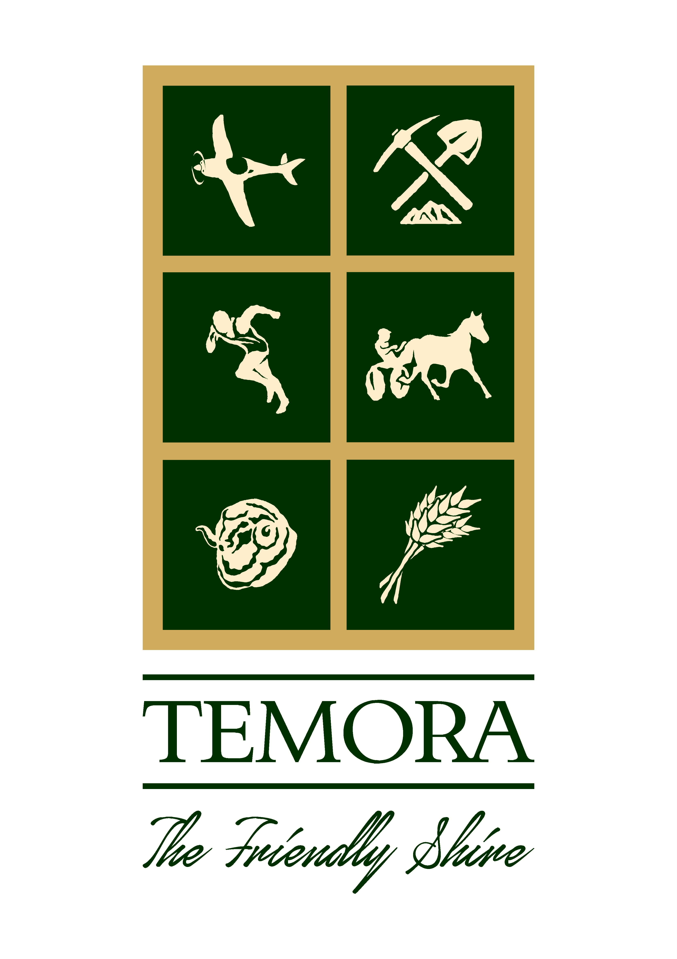
Temora Shire Council
CITIZEN of the Year 2022
(19 years and over)

I hereby nominate:-

……………………………………………………………………………………………………………………………
for the award of Citizen of the Year 2022

Nominee Name: ……………………………………………………………………………………………………….

Nominee Address: ……………………………………………………………………………………………………

Nominee Ph No:………………………………………………………………………………………………………

Brief reasons for the nomination:-

………………………………………………………………………………………………………………………………………………………………………………………………………………………………………………………………………………………………………………………………………………………………………………………………………………………………………………………………………………………………………………………………………………………………………………………………………………………………………………………………………………………………………………………………………………………………………………………………………………………………………………………………
Additional Supporting Information (ATTACH OTHER RELEVANT DOCUMENTS)
…………………………………………………………………………………………………………………………………………………………………………………………………………………………………………………………………………………………………………………………………………………………………………………………………………………………………………………………………………………………………………………………………………………………………………………………………………………………………………………………………………………………………………………………………………………………………………………………………………………………………………………………………………………………………………………………………………………………………………………………………………………………………………………………………………………………………………………………………………………………………………………………………………………………………………………………………………………………………………………………………………………………………………………………………………………………………
……………………………………………………………………………………………………………………………
…………………………………………………………………………………………………………………………………………………………………………………………………………………………………………………………………………………………………………………………………………………………………………………………………………………………………………………………………………………………………………………………………………………………………………………………………………………………………………………………………………………………………………………………………………………………………………………………………………………………………………………………………………………………………………………………………………………………………………………………………………………………………………………………………………………………………………………………………………………………………………………………………………………………………………………………………………………………………………………………………………………………………………………………………………………………………………………………………………………………………………………………………………………………………………………………………………………………………………………………………………………………………………………………………………………………………………………………………………………………………………………………………………………………………………………………………………………………………………………………………………………………………………………………………………………………………………………………………………………………………………………………………………………………………………………………………………………………………………………………………………………………………………………………………………………………………………………………………………………………………………………………………………………………………………………………………………………………………………………………………………………………………………………………………………………………………………………………………………………………………………………………………………………………………………………………………………………………………………………………………………………………………………………………………………………………………………………………………………………………………………………………………………………………………………………………………………………………………………………………………………………………………………………………

Name of Nominator:………………….…………………………………. Signed:…………………………………

Contact No. of Nominator:……………………………………………… Date:……………………………………

NOMINATIONS CLOSE: Friday 28 October 2022 at 4:30pm

PLEASE NOTE: THE NOMINATIONS MAY BE DELIVERED TO TEMORA SHIRE COUNCIL OFFICE. THE PREVIOUS YEARS WINNERS OF ALL CATEGORIES ARE INELIGIBLE TO BE NOMINATED AGAIN.

