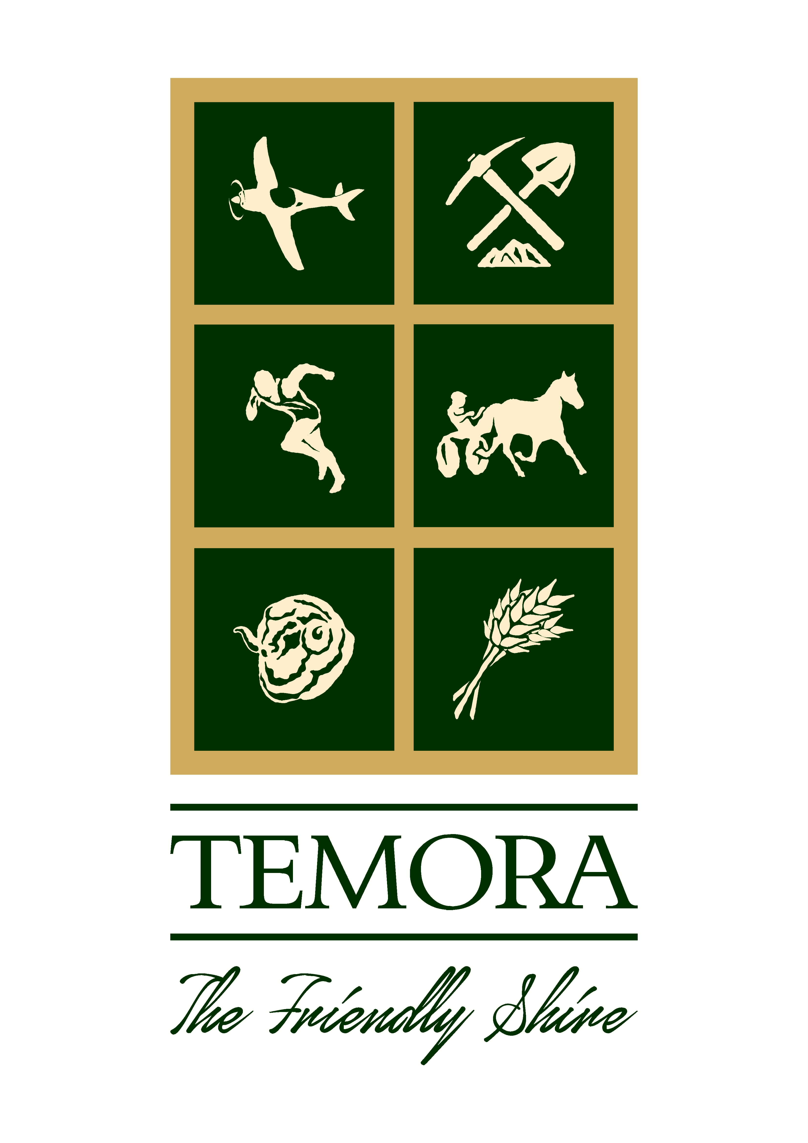
Temora Shire Council
EVENT of the Year 2022

I hereby nominate:-

………………………………………………………………………………………………………………………..
for the award of Event of the Year 2022

Nominee Name: ……………………………………………………………………………………………………

Nominee Address: …………………………………………………………………………………………………

Nominee Ph No:……………………………………………………………………………………………………

Brief reasons for the nomination:-

………………………………………………………………………………………………………………………………………………………………………………………………………………………………………………………………………………………………………………………………………………………………………………………………………………………………………………………………………………………………………………………………………………………………………………………………………………………………………………………………………………………………………………………………………………………………………………………………………………………………………………………………
Additional Supporting Information (ATTACH OTHER RELEVANT DOCUMENTS)
……………………………………………………………………………………………………………………………………………………………………………………………………………………………………………………………………………………………………………………………………………………………………………………………………………………………………………………………………………………………………………………………………………………………………………………………………………………………………………………………………………………………………………………………………………………………………………………………………………………………………………………………………………………………………………………………………………………………………………………………………………………………………………………………………………………………………………………………………………………………………………………………………………………………………………………………………………………………………………………………………………………………………………………………………………………………………………………………………………………………………………………………………………………………………………………………………………………………………………………………………………………………………………………………………………………………………………………………………………………………………………………………………………………………………………………………………………………………………………………………………………………………………………………………………………………………………………………………………………………………………………………………………………………………………………………………………………………………………………………………………………………………………………………………………………………………………………………………………………………………………………………………………………………………………………………………………………………………………………………………………………………………………………………………………………………………………………………………………………………………………………………………………………………………………………………..................................................................................................................................................................................................................................................................................................................................................................................................................................................................................................................................................................................................................................................................................................................................................................................................................................................................................................................................................................................................................................................................................................................................................................................................................................................................................................................................................................................................................................................................................................................................................................................................................................................................................................................................................................................................................................................................................................................................................................................................................................................................

Name of Nominator:………………….…………………………. Signed:…………………………………………..

Contact No. of Nominator:……………………………………………… Date:……………………………………

NOMINATIONS CLOSE: Friday 28 October 2022 at 4:30pm

PLEASE NOTE: THE NOMINATIONS MAY BE DELIVERED TO TEMORA SHIRE COUNCIL OFFICE. THE PREVIOUS YEARS WINNERS OF ALL CATEGORIES ARE INELIGIBLE TO BE NOMINATED AGAIN.

