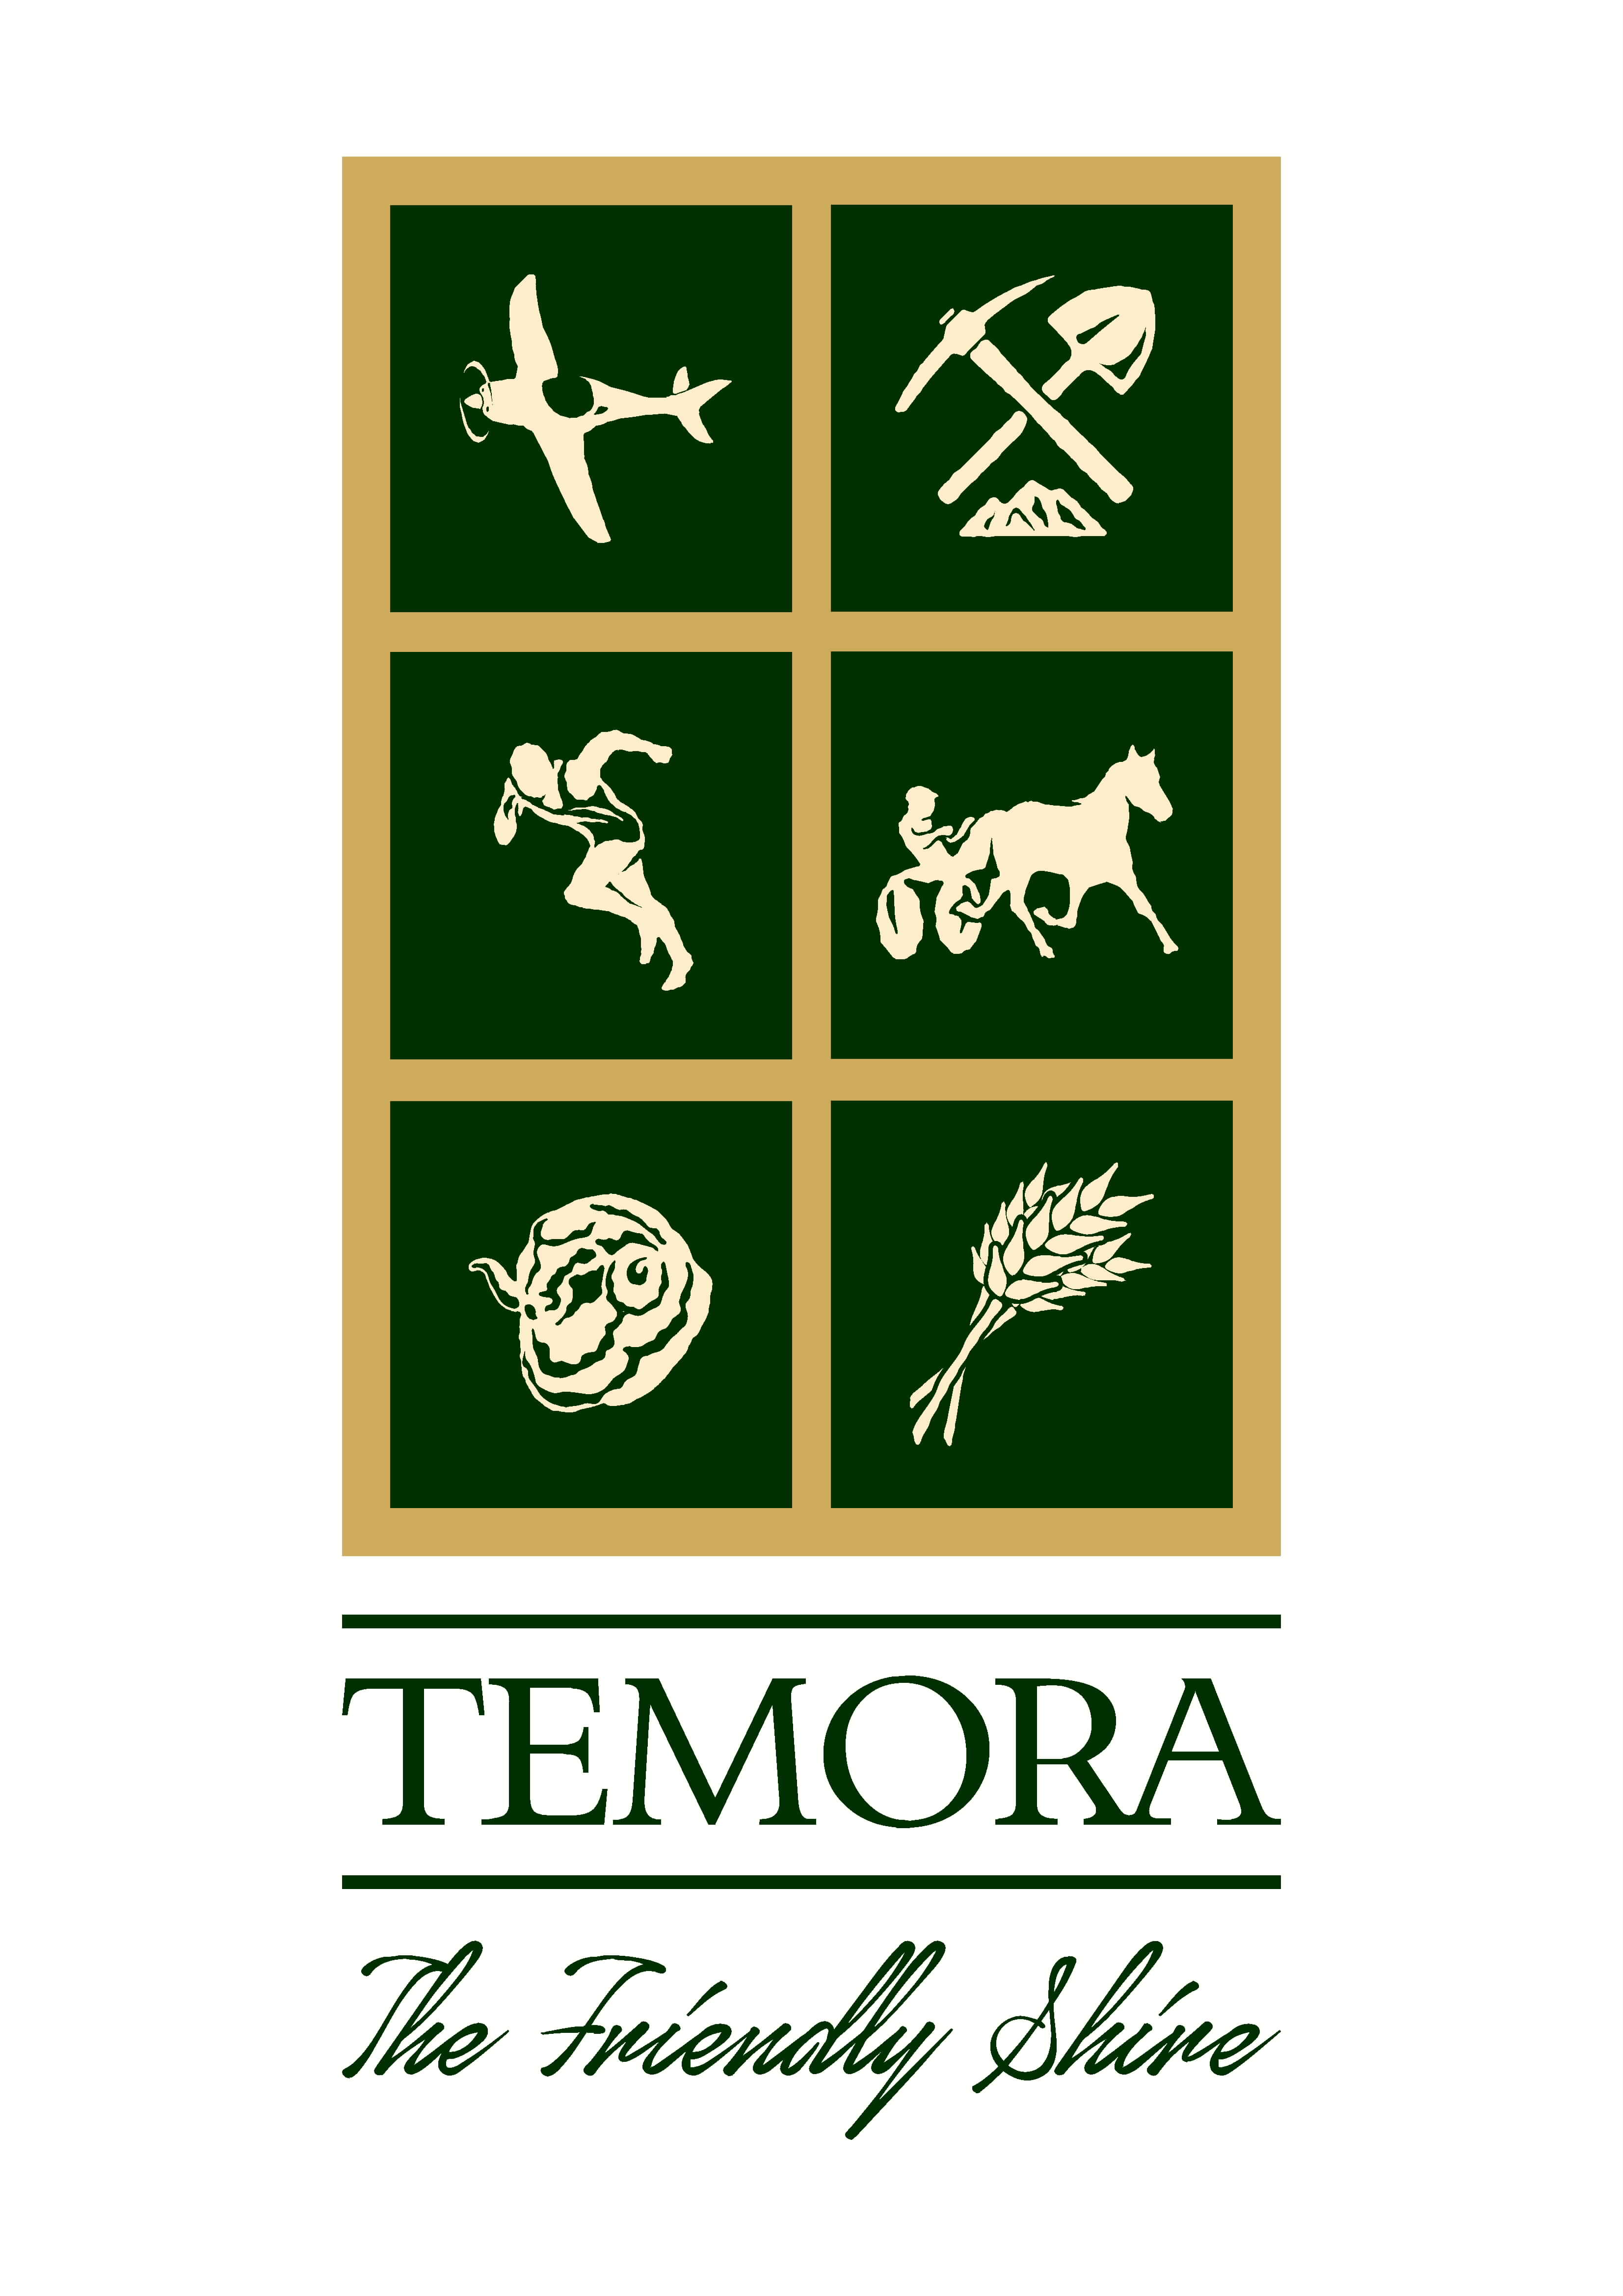
Temora Shire Council
YOUNG CITIZEN of the Year 2022
(10-18 years of age)

I hereby nominate:-

………………………………………………………………………………………………………………………..
for the award of Young Citizen of the Year 2022

Nominee Name: ……………………………………………………………………………………………………

Nominee Address: …………………………………………………………………………………………………

Nominee Ph No:……………………………………………………………………………………………………

Brief reasons for the nomination:-

………………………………………………………………………………………………………………………………………………………………………………………………………………………………………………………………………………………………………………………………………………………………………………………………………………………………………………………………………………………………………………………………………………………………………………………………………………………………………………………………………………………………………………………………………………………………………………………………………………………………………………………………
Additional Supporting Information (ATTACH OTHER RELEVANT DOCUMENTS)
………………………………………………………………………………………………………………………………………………………………………………………………………………………………………………………………………………………………………………………………………………………………………………………………………………………………………………………………………………………………………………………………………………………………………………………………………………………………………………………………………………………………………………………………………………………………………………………………………………………………………………………………………………………………………………………………………………………………………………………………………………………………………………………………………………………………………………………………………………………………………………………………………………………………………………………………………………………………………………………………………………………………………………………………………
………………………………………………………………………………………………………………………………………………………………………………………………………………………………………………………………………………………………………………………………………………………………………………………………………………………………………………………………………………………………………………………………………………………………………………………………………………………………………………………………………………………………………………………………………………………………………………………………………………………………………………………………………………………………………………………………………………………………………………………………………………………………………………………………………………………………………………………………………………………………………………………………………………………………………………………………………………………………………………………………………………………………………………………………………………………………………………………………………………………………………………………………………………………………………………………………………………………………………………………………………………………………………………………………………………………………………………………………………………………………………………………………………………………………………………………………………………………………………………………………………………………………………………………………………………………………………………………………………………………………………………………………………………………………………………………………………………………………………………………………………………………………………………………………………………………………………………………………………………………………………………………………………………………………………………………………………………………………………………………………………………………………………………………………………

Name of Nominator:………………….………………………….. Signed:…………………………………

Contact No. of Nominator:……………………………………….. Date:……………………………………

NOMINATIONS CLOSE: Friday 28 October 2022 at 4:30pm

PLEASE NOTE: THE NOMINATIONS MAY BE DELIVERED TO TEMORA SHIRE COUNCIL OFFICE. THE PREVIOUS YEARS WINNERS OF ALL CATEGORIES ARE INELIGIBLE TO BE NOMINATED AGAIN.

