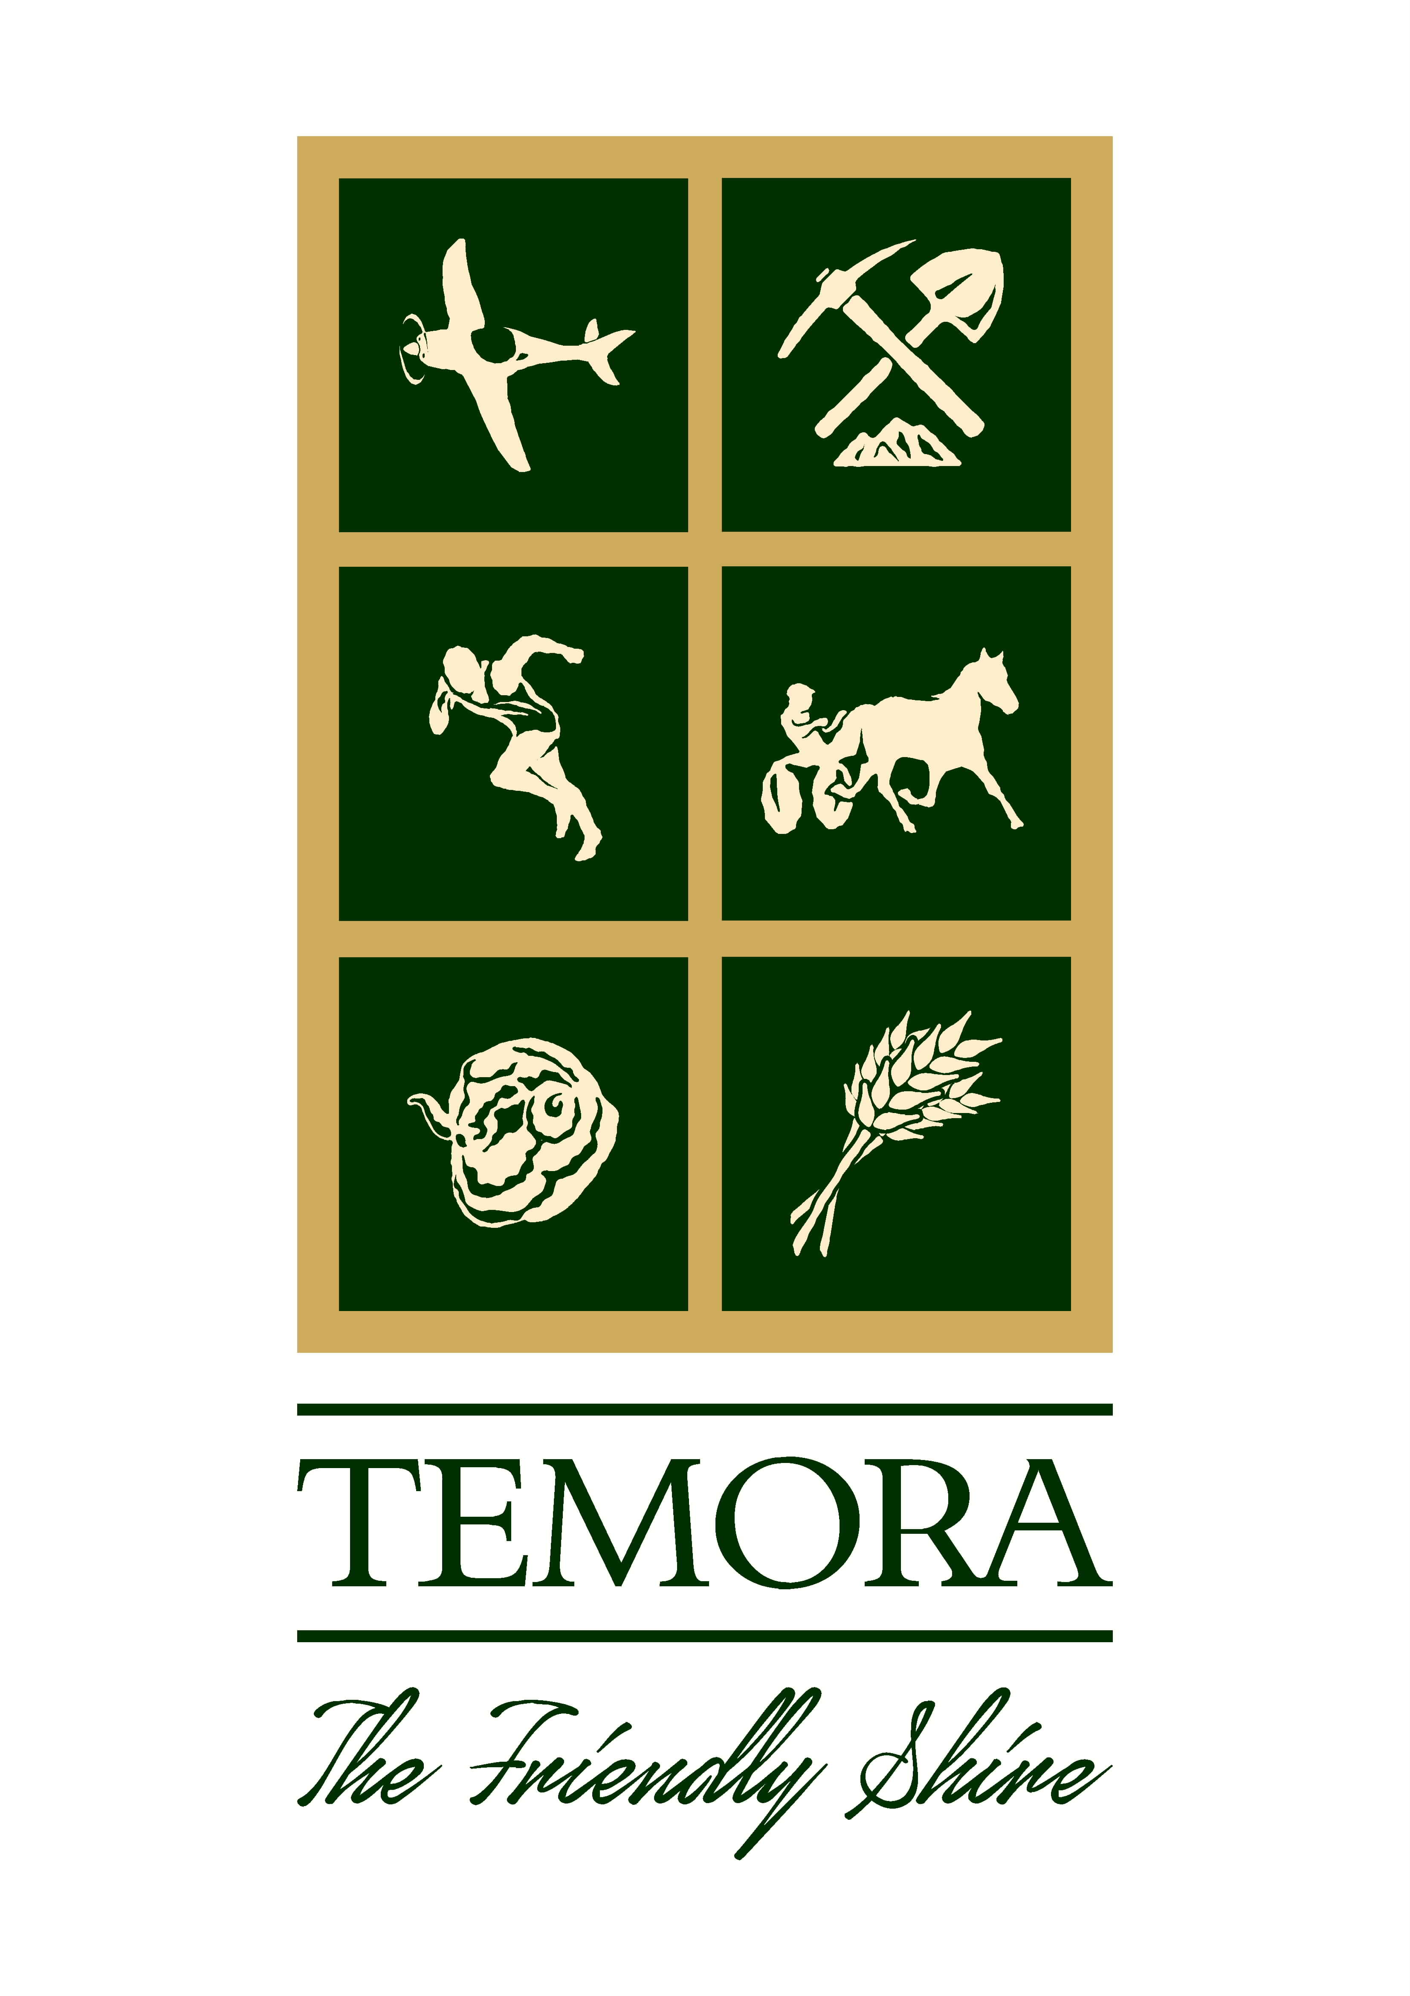
TEMORA SHIRE COUNCIL
BUILDING APPROVALS – January 2022

ENVIRONMENTAL PLANNING & ASSESSMENT ACT, 1979
In accordance with the provisions of Section 4.59 of the Act, and Section 124 of the Regulations, notification is given that the undermentioned developments have recently been granted consent.

DEVELOPMENT APPLICATIONS ISSUED

- DA 86/2021 – Lot 14; DP 832132, Lot 302, 303, 599, 600 & 601; DP750587, Lot A; DP 370331; 232 Loftus Street, Temora – Subdivision – Creating 63 Residential Lots & 11 Industrial Lots
- DA/CC 92/2021 – Lot 7; Section 4; DP 758957; 225 Hoskins Street, Temora – Steel Framed Shed
- DA/CC 94/2021 – Lot 2; DP 521314; 148 Gardner Street, Temora – Carport
- DA/FSS 95/2021 – Lot 2; DP 594010; 288 Hoskins Street, Temora – Convert Existing Shed into Plant Nursery
- DA/CC 96/2021 – Lot 23; DP 1271175; 152 Carson Street, Temora – Dwelling
- DA 97/2021 – Lot 98; DP 750592; 538 Reynolds Lan, Combaning – New Commercial Kitchen and Small Function Centre
- DA 1/2022– Lot 5; Section 3; DP 758030; 32 Ariah Street, Ariah Park – Relocating Existing Shed
- DA 2/2022 – Lot 6; Section 4; DP 758957; 219-221 Hoskins Street, Temora – Subdivision
- DA/CC 3/2022 – Lot 3; Section 15; DP 758957; 103 Deboos Street, Temora – New Steel Framed Shed & Re-Locate Existing Shed
- DA/CC 7/2022 – Lot B; DP 357058; 2 Bowling Club Lane, Temora – Alterations & Additions to Pergola/BBQ Area

COMPLYING DEVELOPMENT CONSENTS ISSUED

- CDC 1/2022 – Lot 1; DP 385123; 63 Deutcher Street, Temora – Steel Framed Shed
- CDC 2/2022 – Lot 1; DP 1043221; 366 Thanowring School Road, Temora – Swimming Pool
- CDC 3/2022 – Lot 3; DP 1255462; 14 Evatt Street, Temora – Steel Framed Shed
- CDC 4/2022 – Lot 20; DP 1073421; 12 Harrier Street, Temora – Steel Framed Shed

Please insert in Temora Independent on: Tuesday 15th February, 2022

Order No: 8540

KJ Dunstan
DIRECTOR OF ENVIRONMENTAL SERVICES

