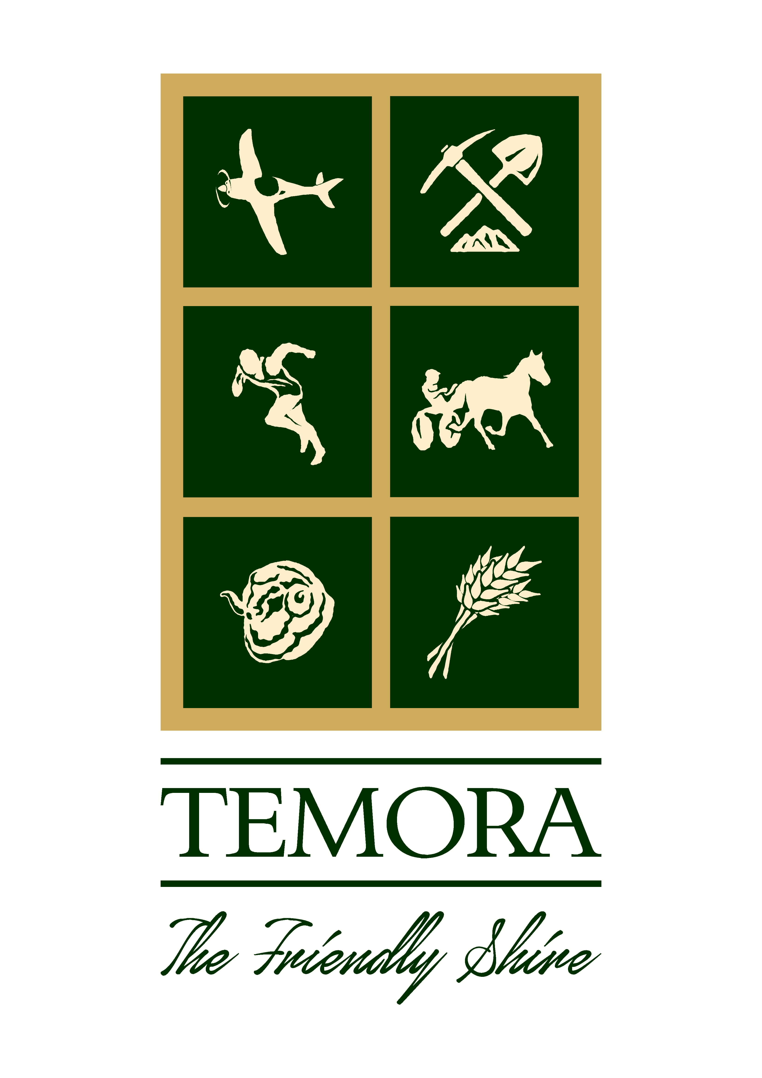
TEMORA SHIRE COUNCIL
BUILDING APPROVALS – JUNE 2022

ENVIRONMENTAL PLANNING & ASSESSMENT ACT, 1979
In accordance with the provisions of Section 4.59 of the Act, and Section 124 of the Regulations, notification is given that the undermentioned developments have recently been granted consent.

DEVELOPMENT APPLICATIONS ISSUED

- DA/CC 30/2022 – Lot 28; DP 807237; 2 Killarney Street, Temora – Shed/Two Bedroom Unit
- DA/CC 32/2022 – Lot 13; DP 1070950; 9 Joffre Street, Temora – S/F Storage Shed and Carport
- DA/CC 34/2022 – Lot 31; DP 1082604; 21 Tigermoth Avenue, Temora – Dwelling
- SUB 36/2022 – Lot 2; DP 217405; 18 Loftus Street, Temora – Subdivision
- DA/CC 40/2022 – Lot 30; DP 5225; 5 Bellevue Street, Temora – Carport & Patio
- DA 42/2022 – Lot 1; DP 623795; 17 Murphy Street, Temora – Transportable Dwelling
- SUB 43/2022 – Lot 464; DP 750587; 72 Bundawarrah Road, Temora – 2 Lot Subdivision
- DA/CC 45/2022 – Lot 13; DP 1236963; 12 Leary Place, Temora – S/F Shed
- DA 46/2022 – Lot 6; Section 3; DP 758957; 276-278 Hoskins Street, Temora – Convert to Food & Drink Premises

COMPLYING DEVELOPMENT CONSENTS ISSUED

- CDC 18/2022 – Lot 4; Section 9; DP 758957; 157 Deboos Street, Temora – Carport & Verandah
- CDC 19/2022 – Lot 2; Section C; DP 6207; 10 Lawson Road, Temora – Steel Framed Farm Shed
- CDC 20/2022 – Lot 13; Section 32; DP 758957; 176 Twynam Street, Temora – Dwelling Alterations & Additions
- CDC 21/2022 – Lot 4; Section A; DP 6207; 4 Mansfield Road, Temora – Dwelling Additions
- CDC 22/2022 – Lot 7; DP 12450; 7 Coolamon Street, Ariah Park – S/F Storage Shed
- CDC 23/2022 – Lot 13; DP 4816 – 142 Vesper Street, Temora - Carport

Please insert in Temora Independent on: Friday 15th July, 2022

Order No: 00620

KJ Dunstan
DIRECTOR OF ENVIRONMENTAL SERVICES

