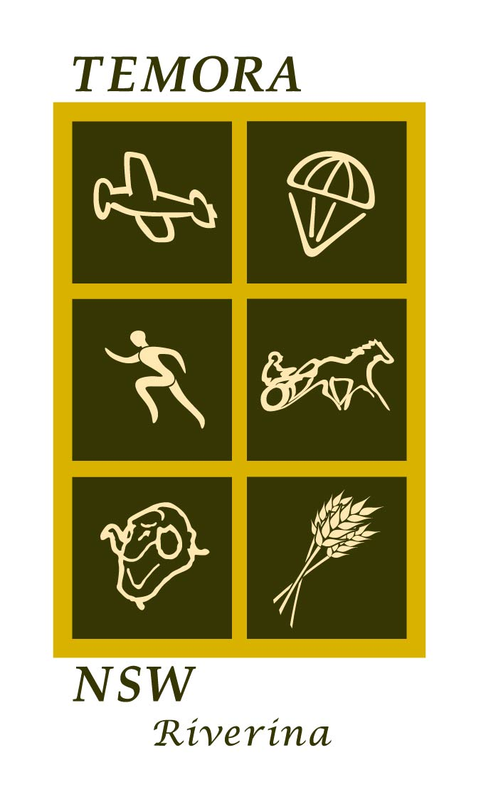
STATEMENT OF ENVIRONMENTAL EFFECTS
For minor development

About this form
Use this form to prepare a Statement of Environmental Effects for minor development such as dwellings and sheds. The Statement describes the likely impacts of your development proposal, and how you propose to lessen those impacts. It is a requirement of the Environmental Planning and Assessment Act.

Completing the form
Answer all questions. If insufficient space, provide an attachment. When completed, sign the form and attach it to your development application.

Infrastructure & Access
- Are existing utility Water: Yes / No Sewer: Yes / No
services adequate?
If NO, provide details Electricity: Yes/ No Telephone: Yes / No

2. Is access to the site Legal access: Yes / No
adequate? All weather vehicle access: Yes / No
If No, provide details Waste collection access: Yes / No
Emergency/bushfire access: Yes / No
Car parking: Yes / No

- Existing Fire Safety Measures:

Natural resources
- What is the current
state of the site?
Do you know what the site has
been utilised for in the past?

- Will trees or Trees: Yes / No
vegetation be Number, size & species:
removed or affected? Native vegetation: Yes / No
If YES, describe how you will Type of vegetation:
mitigate impacts on habitat Mitigation measures:
and species, eg, areas to be
fenced off, replanting,
regeneration Is there a Property Vegetation Plan applicable to this property?
Yes / No

5. Is the land affected by Flooding: Yes No Bushfire prone: Yes / No
natural hazards or risks? Salinity: Yes No Steep slopes >18* Yes / No
Landslip: Yes No Subsidence Yes / No
Please check Council maps. If
YES, describe how you have
taken relevant guidelines into
account (e.g. RFS Guidelines)

- How will stormwater Connection to street gutter: Yes / No
be managed? Water tank: Yes / No
Attach details Other:

- Will the ground surface Yes No
be disturbed?
If YES, describe how will
you control erosion,
sedimentation and dust?

- Is a septic tank or
similar device Yes / No
proposed? Type: Size:

Design issues
- Are there any impacts Privacy: Yes No Overshadowing: Yes / No
on neighbours? Views: Yes No Noise: Yes / No
If YES, describe measures Odours: Yes No Bright light/ glare: Yes / No
to reduce impacts, such
as setbacks, fencing,
screening, odour controls

- Are there any impacts Character: Yes / No Height/density: Yes / No
on local amenity? Streetscape: Yes / No Appearance: Yes / No
If YES, describe measures Colour: Yes / No Landscaping: Yes / No
to reduce impacts, such
as architectural & landscape
design

- Will a heritage item, Yes No
heritage conservation
area or Aboriginal
site be affected:
Discussed with Council’s Heritage Advisor? Yes / No
If YES, describe how you will
avoid impacts

- Have measures been Appropriate orientation: Yes / No
taken to improve Eaves, awnings & shading Yes / No
energy and water Insulation (ceiling, walls, windows): Yes / No
efficiency: Rainwater harvesting Yes / No
If YES, attach details of BASIX certificate attached: Yes / No
Proposed measures

- Is any advertising or Yes / No
signage proposed?
If YES, attach details of size,
location, graphics, text, etc

- Are there any other Yes / No
possible impacts?
If YES, give details. How
will you reduce these impacts?

Signature
15. Your declaration I declare that the information contained in this statement is,
Must be completed by to my knowledge, true and correct
the applicant
Signature: Date:

