

TEMORA SHIRE COUNCIL

^{LOCAL HERITAGE}

^{ASSISTANCE FUND}

FUNDING APPLICATION

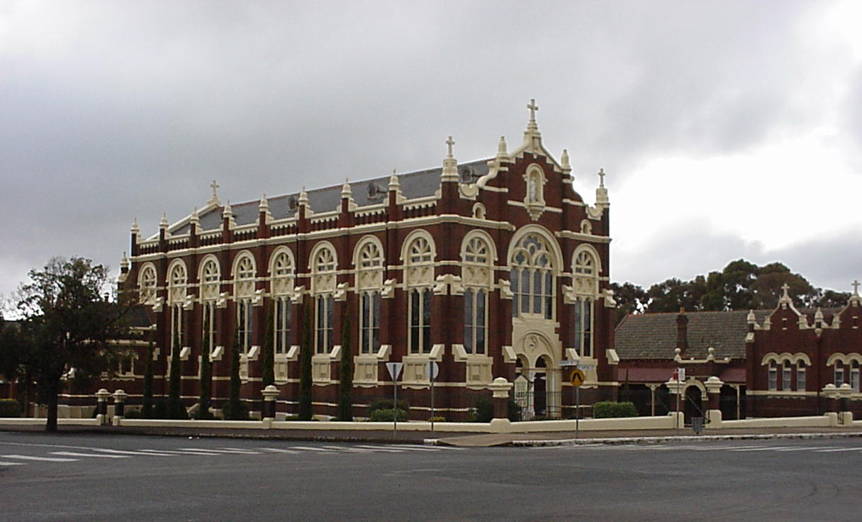

LOCAL HERITAGE ASSISTANCE FUND FOR TEMORA SHIRE

BACKGROUND

A local Heritage Fund has been established by Temora Shire Council with the aid of a grant from the Heritage Office of the NSW State Government. There is a total of $10,000.00 in the fund for twelve months. This is made up of a NSW State Government Grant of $5,000.00 and $5,000.00 from Temora Shire Council.

AIM OF THE FUND

The aim of the project is to encourage as much positive work on heritage items in the area as possible. In the past, many grant programs were for individual buildings only. This program will provide kick-start funding to encourage the joint funding of a number of projects. In the process, it is hoped that this will engender greater interest and concern for conservation for all other heritage items within the Council’s area.

INVITATION TO APPLY

Owners of heritage buildings in this area are invited to apply as well as owners of those buildings not currently listed but of heritage or streetscape significance. It is essential that you prepare the best application possible because of the limited funds and these guidelines have been prepared to assist you.

ELIGIBLE PROJECTS

Projects which involve the repair, maintenance or reinstatement of missing items on heritage buildings in the nominated area. These include fences, verandahs, roof cladding, external painting, shopfront tiling and decorative detail. Projects include structural work through to final painting of projects.

PROJECTS NOT FUNDED

Funding will generally NOT be provided for the following projects: where assistance is reasonably available from another source; where substantial assistance has been previously provided; or where the applicant has yet to complete other assisted projects. Additionally, the following items will also not be considered:

- purchase of a building, site or moveable item;
- a new addition to a heritage building (including new internal fittings such as new kitchen and bathrooms);
- the re-location of a heritage building or work on a re-located building;
- work on a government owned building still used for a government purpose.

ASSESSMENT CRITERIA

The following matters will be taken into account by the Council in assessing the priority of your application. Please note that it is not necessary for your project to meet all of these criteria:-

- Projects which are highly visible to the public eg. the replacement of a verandah to a building in a main street location, providing appropriate signage and painting in a colour scheme in accordance with Heritage Adviser recommendations;

- The applicant’s ability to demonstrate technical and financial responsibility with regard to the project, and demonstrated ability to complete the project within twelve months;

- The applicant’s ability to demonstrate technical and financial responsibility with regard to the project, and demonstrated ability to complete the project within twelve months;

- Projects which would encourage the conservation of other heritage items;

- Projects of demonstrated heritage value to the community; commonly the item concerned will appear on many heritage lists, eg. the restoration of an important local heritage house;

- Projects which have high public accessibility, eg. a local museum, church or a private home which is open to the public several times a year;

- Projects involving aspects of heritage which have received little or no funding eg. historic gardens;

- Projects subject to conservation controls where the owner is able to show hardship arising from conservation work required to the item; and

- Urgent projects to avert a threat to a heritage item.

LEVEL OF FUNDING AVAILABLE

It is proposed that the maximum level of funding per project will be limited to $1,000.00. Greater funding may be made if the circumstances warrant it. You will be required to provide at least matching finance for the projects. There will clearly be cases where you may yourself wish to contribute more to the project.

TIMING OF PROJECTS

From approval you will have twelve months to complete your project.

WHAT YOU NEED TO DO

Firstly, contact the Heritage Adviser for your area.

It is suggested that you set down the work you propose to do and then contact the Heritage Adviser to discuss the eligibility and other details of your project. This service is provided free of charge. The Adviser will be able to assist you in making an application. If the project is too large the adviser may suggest that you get the services of a conservation architect for the project.

The Heritage Adviser is David Scobie and you can make an appointment by ringing Council on (02) 6980 1100.

Background Research

It will assist your case if you can properly demonstrate why the work you propose is appropriate from a heritage point of view. To do this you may need to do some research, eg. the Council may have information on the building, or the library or you may be able to obtain photographs. The heritage adviser may also have some suggestions to follow up.

Work to be carried out

You then need to decide in detail what work you want to carry out. This should be put down in a clear item by item job schedule.

Quotes

Next, as with any work, you need to get quotes and it is suggested that you get at least two for the work. Put these costs alongside the schedule of work you have prepared.

Plans and Sketches

Depending upon the size of the job you may need these to attach to your application for funding.

Photographs

Take a photograph of the setting of the building, each elevation and close-ups of any particular job to be done. Keep the negatives and a set of photographs for your final report.

Fill in the application form

Fill in the attached simple form, keep a copy for your records, staple on the attachments and take it immediately to the Council.

Building Approval

Depending on the type of work which you intend to carry out, you may require Council’s building approval. This is separate to this application. Council can provide advice in this area.

TEMORA SHIRE COUNCIL

^{LOCAL HERITAGE ASSISTANCE FUND}

APPLICATION FOR FINANCIAL ASSISTANCE

Please refer to guidelines before completing this application.

APPLICANT

NAME: ………………………………………………………………………………………
POSTAL ADDRESS: ……………………………….…………………………….……
………………………….…………………………….……
………………………… POST CODE: …………………………..
TELEPHONE NO. (HOME): ……………………… (BUSINESS): ………………………….
^{FACSIMILE: ………………………………….} ^{E-MAIL: ……………………………………}

SUBJECT LAND

^{NO: ………………………….} ^{STREET: …………………………………………..……}
LOCATION: …………………………………………………………………………………………...

THE PROPOSAL

PROPOSED WORKS: …………………………………………………………………..…….
……………………………………………………………………………………………..……..
………………………………………………………………………………………………..…..
……………………………………………………………………………………………..……..
…………………………………………………………………………………………..………..
…………………………………………………………………………………………………….
…………………………………………………………………………………………………….
…………………………………………………………………………………………………….
…………………………………………………………………………………………………….
…………………………………………………………………………………………………….
…………………………………………………………………………………………………….

PRESENT USE OF BUILDING: ……………………………………………………………….
…………………………………………………………………………………………………….
……………………………………………………………………………………………………..
……………………………………………………………………………………………………..
……………………………………………………………………………………………………..

FUNDS

ESTIMATED COST OF WORKS: ……………………………………………………………..

THE AMOUNT YOU ARE SEEKING WITH THIS APPLICATION: $………………………
(NOTE: MAXIMUM $1,000.00 AMOUNT SOUGHT MUST BE MATCHED DOLLAR FOR DOLLAR BY APPLICANT)

ADDITIONAL INFORMATION SUBMITTED WITH THIS APPLICATION:

Please tick ()

Quotes for the costs to carry out work

Tradesmen qualifications/experience

Plans/sketches of the proposed works

Photographs of existing structure

Samples of finished materials/colours

Historical background of the Property

SIGNATURE OF APPLICANT

I/We, the undersigned, being the applicant/s nominated in this application, hereby apply for financial assistance under the Local Heritage Assistance Fund to carry out works described in this application on the land specified in this application.

………………………………………. ………………………………… ……………..……
Signature/s Capacity Date

CONSENT OF OWNER/S OF LAND

NAME OF OWNER/S OF LAND: ……………………………………………………………...

POSTAL ADDRESS: …………………………………………………………………………...

…………………………………………………………………………...

I/We, the undersigned, being the owner’s nominated above of the land to which this application relates, hereby consent to the making of this application.

………………………………………. ………………………………… ……………..……
Signature/s Capacity Date

AGREEMENT FOR FINANCIAL ASSISTANCE OFFERED UNDER
^{OFFICE USE}
TEMORA SHIRE HERITAGE PROGRAM

(This cover sheet should be used for all projects)

PROJECT NUMBER:

DETAILS OF ASSISTANCE:

Applicants Name:

Postal Address:

Project Address:

Project Name:

Amount of Assistance: $ Type: Your Contribution: $

Funding Source:

Purposes of the Assistance:

Special Conditions:

Final date for the completion of the project:
CONDITIONS APPLYING TO ALL PROJECTS

You, the applicant, by entering into this agreement, agree to comply with the following conditions:-

1. Acceptance
You must accept this offer of assistance within six (6) weeks of the date of this offer otherwise it will be withdrawn.

2. Permission to Commence Work
You must provide the following information before permission to commence work will be granted:-

a) a draft schedule of work and quotations;
b) who is to carry out the work;
c) a time schedule for the completion of the project;
d) name of a suitably qualified person who will be responsible for supervising the proposed work.
e) historical background of the property, with heritage photographs where available.

3. Funding from Other Sources
You must immediately advise the council of any changes to financial resources and arrangements connected with the project.

4. Claims

Claims for payment should be supplied in letter form and you should set out clearly what work was carried out, by whom and how much you are claiming. Please attach originals of any bills.

5. Progress Reports

You must provide brief progress reports as requested.

6. Revocation

You agree that this financial assistance may be reviewed or revoked at any time under any one or more of the following circumstances:

a) Unsatisfactory work;
b) Failure to meet time schedule constraints;
c) Failure to provide progress reports;
d) Non disclosure, misleading or false disclosure of information.

You also agree, in case of revocation, that where monies have been advanced you are obliged to refund those monies plus interest equal to the current rate used for local government rate arrears.

7. Taxation and Other Regulations
You agree that it is solely your responsibility to ensure that you comply with any taxation liability and or regulations under any Federal or State legislation.

8. Loan and Index Refundable Grant Conditions
You agree to enter into a separate agreement to provide whatever form of security for this assistance which may be required.

9. Re-useable Equipment
You agree that assistance is not to be used for expenditure on re-useable equipment without the prior written approval of the Council.

10. Appropriate Conservation Work and Financial Management
You agree that all work must be carried out in a manner consistent with appropriate conservation practice and in accordance with generally accepted sound financial practice.

11. Long Term Protection
You agree to take all reasonable measures to protect in perpetuity the item for which this assistance is granted.

You the applicant, and owner of the item assisted, agree not to object to the inclusion of the item in a Local Environment Plan where this is not already the case.
You agree to insure and keep insured at all times the item for which this assistance is granted.
12. Acknowledgment of Assistance
You agree to acknowledge this assistance in any form required and approved by the Council.

Acceptance

You the applicant, hereby agree to the above conditions and accept this offer of assistance.

Signature: ………………………………………. Date: ………………………

To be completed for projects where the applicant is not the owner of the item being conserved.

I, the owner of the item for which this assistance is granted, also agree to the conditions of this assistance and give permission for work to commence.

Signature: ……………………………………… Date: …………………………

