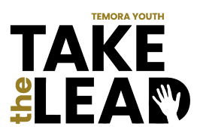
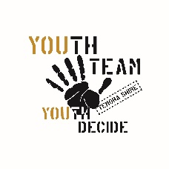
TAKE THE LEAD
Applicant Support Document
To be completed and submitted separately by applicant’s employer, school or community organisation.
Thank you for supporting The Temora Youth Leadership Program TAKE THE LEAD, which aims to raise the leadership aspirations young people in our community (aged 15 to 20 years). Skills addressed in this program include: communication and interpersonal skills; self-reflection; public speaking; establishing connections and team building- skills which will benefit your business/ organisation. Attendance at each session is compulsory.
Name of business, school or community group: __________________________________________
Name of contact person: _____________________________________________________________
Contact email: _____________________________________________________________________
Contact phone number: _____________________________________________________________
Name of applicant: _________________________________________________________________
NOTE: Participants are expected to attend every session.
SESSION | DATE, TIME & VENUE | DETAILS
Session 1 | Monday 29th August  4.30-5.30 pm  Platform Y | Meet, greet and program overview  Program facilitators: Sheree Elwin- TSC Youth Development Officer  Ruth Sinclair- People and Culture Consultant & Leadership Coach
Session 2 | Friday 9th September  4.30 pm -6.30 pm  Temora Town Hall foyer | Official Program Launch (finger food provided).  Participants and invited guests
Session 3 | Monday 12th September  4pm -6pm  Platform Y | Express myself: Public speaking and presentation skills  Presenter TBC
Session 4 | Monday 19th September  4.30-6.30 pm  Temora Aviation Museum | Explore: What’s happening at the local level?  Craig Sinclair- TSC Economic Development Manager  Mel Gallagher- Business owner and TBEG Chairperson  Cindy Cassidy- Director, SNSW Drought Innovation Hub CSU  Pete Harper- Deputy CEO Temora Aviation Museum
Session 5 | Sunday 9th October  1pm -3 pm  Temora Recreation Centre | All for one, and one for all- teamwork  Megan Fritsch. Founder SportConnect; President of the Career Industry Council of Australia (CICA)
Session 6 | Monday 10th October  4pm -6 pm  Platform Y | So, what next? Getting your bearings and taking action  Josh McCrone- former professional athlete; electrician  Kim Sandgren- Inspired Health and Prosperity
Graduation Dinner | Saturday 22nd October  6.30pm- 9.30 pm  Temora Town Hall | Dinner and special guest speaker

Do you endorse this applicant? Yes No If yes, briefly outline why you support their application.
__________________________________________________________________________________________________________________________________________________________________________________________________________________________________________________________________________________________________________________________________________________________________________________________________________________________________________________________________
Do you give permission to use your name and business/ school/ community group to be used in the promotion of this program?
Yes No

I hereby endorse the nomination of ____________________________________ for the TAKE THE LEAD
Temora Youth Leadership Program. I understand they are required to attend workshops from on the dates
outlined above.
Signed: ____________________________ Print name: ____________________________Date: __________
Return via email to: selwin@temora.nsw.gov.au OR Temora Shire Council, by 4PM Friday 19th August

