INFORMATION GUIDE



Temora Shire Council

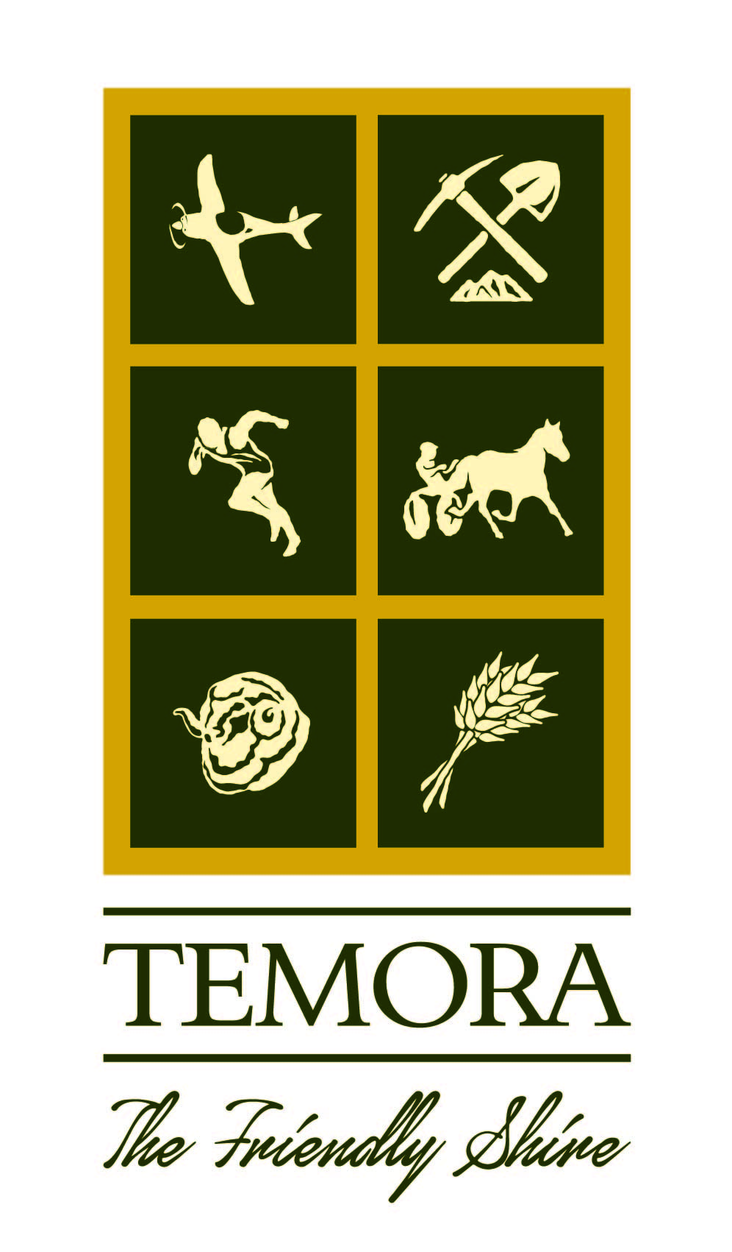
105 Loftus Street
TEMORA NSW 2666
Phone: (02) 69801100
Fax: (02) 69801138
Email: temshire@temora.nsw.gov.au
Web: temora.nsw.gov.au

VISION, MISSION AND VALUES 4
OUR VISION 4
OUR MISSION 4
ORGANISATIONAL STRUCTURE AND RESOURCES 5
FUNCTIONS OF TEMORA SHIRE COUNCIL 9
FUNCTIONS OF TEMORA SHIRE COUNCIL 10
SERVICE FUNCTIONS 10
REGULATORY FUNCTIONS 10
ANCILLARY FUNCTIONS 11
REVENUE FUNCTIONS 11
ADMINISTRATIVE FUNCTIONS 11
ENFORCEMENT FUNCTIONS 12
FUNCTIONS CONFERED UNDER OTHER ACTS 12
COMMUNITY PARTICIPATION IN COUNCIL’S POLICY FORMATION AND THE EXERCISE OF FUNCTIONS 12
REPRESENTATION 13
PERSONAL PARTICIPATION 13
COMMUNITY CONSULTATION 13
INFORMATION HELD BY TEMORA SHIRE COUNCIL 14
INFORMATION HELD BY COUNCIL 14
FILES 14
POLICY INFORMATION 14
GENERAL INFORMATION 14
HOW DO THE PUBLIC ACCESS INFORMATION UNDER THE GIPA ACT? 15
WHAT INFORMATION IS OPEN ACCESS INFORMATION? 15
PUBLICLY AVAILABLE INFORMATION 16
APPROVALS, ORDERS AND OTHER INFORMATION 17
WHAT INFORMATION IS COUNCIL NOT ALLOWED TO RELEASE? 18
ACCESS TO COUNCIL INFORMATION 18
PUBLIC OFFICER AND RIGHT TO INFORMATION OFFICER 19
OFFICE OF THE INFORMATION COMMISSIONER 19

This Information Guide is a mandatory requirement under Section 20 of the Government
Information (Public Access) Act 2009 (GIPA Act). The Act requires Council to produce an Information Guide within six months of the commencement of the Act, being 1 July 2010, with a view to amending and adopting the Information Guide at intervals of not more than 12 months.

The Information Guide describes the structure and functions of Council and how these
affect the community; specifies ways the community can participate in decision making
and provides information about the various kinds of information Council holds and how
the public can access the information.

VISION, MISSION AND VALUES

OUR VISION

Our community strives to reflect the qualities of its greatest asset – its people, each of whom we value as individuals.

With our rural heritage as our foundation, we embrace change and grasp every opportunity to enhance our environment, economy and lifestyle.

OUR MISSION

To achieve the best possible outcomes for our community by striving for excellence in all we do.

OUR CORE VALUES

We will make the best decisions we can, through:
- Leadership and Respect – we will act decisively with knowledge and courage in the best interest of all our community

- Integrity and Transparency – we will act honestly and openly in all our dealings with a view to making ethical and equitable decisions

We will always act with the community as our primary consideration, through:
- Community Focus – we will engage with our community to provide services that respond to community need

- Future Custodianship – we will always act with consideration of the impact of our actions on future generations

We will value the views and input of others, through:
- Teamwork and Cooperation – we will work together with open communication to achieve a common goal by sharing knowledge and supporting each other

- Effective Partnerships – we will treat everyone with respect by being inclusive, non-judgmental and valuing diversity

We will maximise our opportunities, through:
- Innovation – we will encourage creative thinking and innovation based on detailed knowledge and accept that bold actions carry a degree of risk

- Continuous Improvement – we will always strive to achieve our goals more efficiently through improvements in process or new technology

ORGANISATIONAL STRUCTURE AND RESOURCES

The Temora Shire Council is constituted under the NSW Local Government Act 1993.
The leadership of Temora Shire Council is provided under nine Councillors, one of
whom is the Mayor, who are elected by the residents and ratepayers of the Shire.
Councillor elections are held every four years, the current Councillors were elected in
September 2016. The Mayor is elected bi-annually in a ballot by fellow Councillors, which was conducted on 17 September 2020; Councillor Rick Firman was elected Mayor.

The Role of the Mayor is to:

- to be the leader of the council and a leader in the local community,

- to advance community cohesion and promote civic awareness,

- to be the principal member and spokesperson of the governing body, including representing the views of the council as to its local priorities,

- to exercise, in cases of necessity, the policy-making functions of the governing body of the council between meetings of the council,

- to preside at meetings of the council,

- to ensure that meetings of the council are conducted efficiently, effectively and in accordance with this Act,

- to ensure the timely development and adoption of the strategic plans, programs and policies of the council,

- to promote the effective and consistent implementation of the strategic plans, programs and policies of the council,

- to promote partnerships between the council and key stakeholders,

- to advise, consult with and provide strategic direction to the general manager in relation to the implementation of the strategic plans and policies of the council,

- in conjunction with the general manager, to ensure adequate opportunities and mechanisms for engagement between the council and the local community,

- to carry out the civic and ceremonial functions of the mayoral office,

- to represent the council on regional organisations and at inter-governmental forums at regional, State and Commonwealth level,

- in consultation with the Councillors, to lead performance appraisals of the general manager,

- to exercise any other functions of the council that the council determines

The role of a Councillor, as an elected person:

- A Councillor is accountable to the local community for the performance of the council

The Chief Executive Officer of Council is the General Manager. The General Manager is responsible for the efficient and effective operation of Council’s organisation and for ensuring the implementation, without undue delay, of decisions of Council.

The role of The General Manager:

- to conduct the day-to-day management of the council in accordance with the strategic plans, programs, strategies and policies of the council,

- to implement, without undue delay, lawful decisions of the council,

- to advise the mayor and the governing body on the development and implementation of the strategic plans, programs, strategies and policies of the council

- to prepare, in consultation with the mayor and the governing body, the council’s community strategic plan, community engagement strategy, resourcing strategy, delivery program, operational plan and annual report

- to prepare, in consultation with the mayor and the governing body, the council’s community strategic plan, community engagement strategy, resourcing strategy, delivery program, operational plan and annual report

- to ensure that the mayor and other Councillors are given timely information and advice and the administrative and professional support necessary to effectively discharge their functions,

- to exercise any of the functions of the council that is delegated by the council to the general manager

- to appoint staff in accordance with the organisation structure determined under this Chapter and the resources approved by the council

- to direct and dismiss staff

- to implement the council’s workforce management strategy

- any other functions that are conferred or imposed on the general manager by or under this or any other Act.

To assist the General Manager in the exercise of these functions, there are three
departments of Council. These departments are Administration & Finance, Engineering and Environmental. Administration & Finance and Environmental departments are headed by a Director.

GENERAL MANAGER
Mr G C Lavelle

DIRECTOR OF
ADMINISTRATION & FINANCE

Mrs E Smith
(Public Officer)

Administration
- Administration Services
- Financial Management
- Human Resources
- Information Technology
- Records Management

Aged & Disability Services
- Aged Care/Seniors
- Home & Community Care
- Disability Services

Community Services
- Childcare
- Cultural Services
- Education
- Library Services
- Youth

Resident Services
- Community Safety
- Customer Relations
- Service NSW
- Villages
- Volunteers

Economic Development
- Economic Development

MANAGER OF ENGINEERING
SERVICES

Mr R Fisher

Aerodrome

Emergency Services
- Rural Fire Service
- State Emergency Service

Engineering Works
- Mining
- Noxious Plants
- Parking
- Street Lighting
- Street Trees

Recreational Services
- General Recreation
- Parks & Gardens
- Sporting Grounds

Sewerage Services
- Effluent Reuse Scheme
- Sewerage Scheme

Support Services
- Depot & Workshop
- Plant & Equipment

Transport Infrastructure
- Footpaths & Cycleways
- Road Infrastructure
- Road Safety

Water Services
- Drainage
- Water Cycle Management

DIRECTOR OF ENVIRONMENTAL SERVICES

Mr K J Dunstan

Commercial Services
- Caravan Parks
- Saleyards

Environmental Services
- Climate Change
- Environmental Management

Heritage Services
- Heritage
- Rural Museum

Property Services
- Cemeteries
- Council Properties
- Public Toilets
- Swimming Pools
- Temora Recreation Centre
- Temora Town Hall

Public Health
- Food Control
- Community Health Programs

Regulatory Control
- Animal Control
- Building Control
- Land Use Planning
- Regulatory Control

Waste Services
- Garbage & Trade
Waste
- Street Cleaning

MANAGEMENT
TEAM

Mr G C Lavelle

Governance
- Council Relationships
- Governance
- Lobbying & Advocacy

Risk Management
- Occupational Health & Safety
- Risk Management

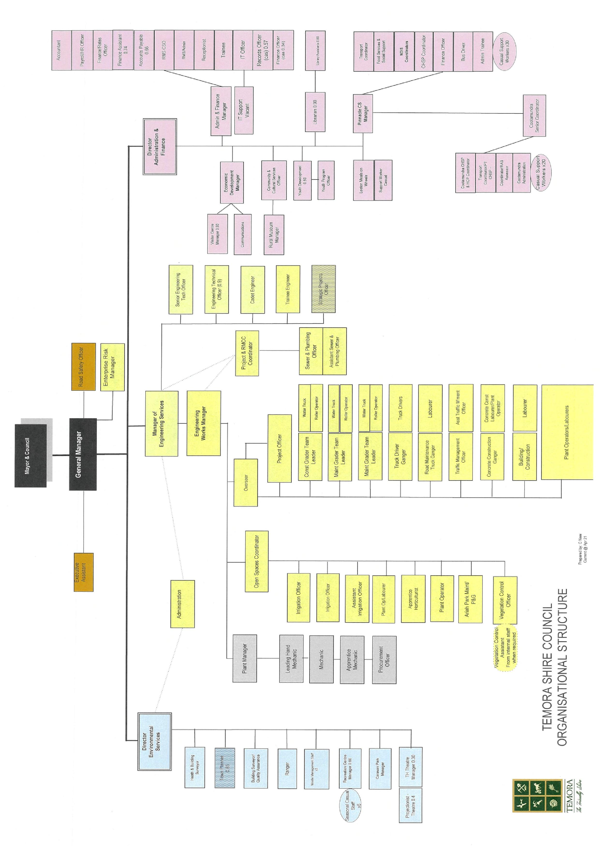

FUNCTIONS OF TEMORA SHIRE COUNCIL

The functions of Council are set out in the Local Government Act and fall into six
categories. The following is an outline of the functions of Council and show how these
functions impact the community.

SERVICE FUNCTIONS

• Provision of community health, recreation, education and information services;

• Environmental protection, conservation and improvement services and facilities;

• Waste removal and disposal;

• Land and property, industry and tourism development and assistance;

• Civil infrastructure planning;

• Civil infrastructure maintenance and construction;

• Cultural, educational and information services and facilities;

• Sporting recreational and entertainment services and facilities; and

• Pest eradication and control services and facilities.

The service functions of Council are a major way in which Council affects the community, as these functions are for the community. Some of the major services provided to the community are infrastructure, waste disposal, and sewerage, Council’s capital works program as identified in its Delivery Plan, tourism development and
assistance, recreation facilities including town shire pools, libraries, footpaths, roads and
street lighting.

REGULATORY FUNCTIONS

• Approvals;

• Orders; and

• Building certificates.

The regulatory functions of Council ensure that any development promotes community
safety and minimises adverse effects on the social and physical environment. The
regulatory functions place restrictions on developments and buildings to ensure that they
meet certain requirements affecting the amenity of the community and not
endanger the lives and safety of any person.

ANCILLARY FUNCTIONS

• Resumption of land; and

• Powers of entry and inspection.

The ancillary functions of Council give support to and aid in the carrying out of, the other
functions of Council, particularly our service and regulatory functions. This function will
only affect a small number of members in our community and confers on Council the
powers to enter land and buildings and to carry out inspections.

REVENUE FUNCTIONS

• Rates;

• Charges;

• Fees;

• Borrowings; and

• Investments.

The revenue functions of Council affect the public directly in that the revenue from rates
and other charges paid by the public to Council is used by Council to fund the services
and facilities provided to the community.

ADMINISTRATIVE FUNCTIONS

• Employment of staff;

• Operational Plan, Delivery Plan & Resourcing Strategy

• Financial Reporting; and

• Annual Reports.

The administrative functions of Council ensure the efficiency and effectiveness of Council.

Council has in place a number of plans, procedures and policies to ensure this. These
plans, procedures and policies outline to the community what Council is doing and how it
will achieve its objectives and the activities and expenditure of Council.

ENFORCEMENT FUNCTIONS

• Proceedings for breaches of the Local Government Act;

• Prosecution of offences; and

• Recover of rates and charges.

The enforcement functions of Council will only affect those members of the community
who are in breach of certain pieces of legislation. Temora Shire Council is committed to
enforcing legislation to ensure that our community is happy and safe. We achieve this
through fines and penalties.

FUNCTIONS CONFERED UNDER OTHER ACTS

While the main functions of Council are conferred under the Local Government Act, other Acts also confer functions for Council. These include:
Community Land Development Act 1989
Companion Animals Act 1998
Conveyancing Act 1919
Environmental Planning and Assessment Act 1979
Fire Brigades Act 1989
Fluoridation of Public Water Supplies Act 1957
Food Act 2003
Impounding Act 1993
Library Act 1939
Protection of the Environment Operations Act 1997
Public Health Act 1991
Recreation Vehicles Act 1983
Roads Act 1993
Rural Fires Act 1997
State Emergency Service Act 1989
Strata Schemes (Freehold Development) Act 1973
Strata Schemes (Leasehold Development) Act 1986
Swimming Pools Act 1992

COMMUNITY PARTICIPATION IN COUNCIL’S POLICY FORMATION AND THE EXERCISE OF FUNCTIONS

There are two broad ways in which the community can participate in the policy formation
and the general activities of Council. These are through representation and personal
participation.

REPRESENTATION

Local Government in Australia is based on the principle of representative democracy.
This means that the people elect representatives to their Council to make decisions on
their behalf. In New South Wales, local government Councillor elections are held every
four years. The next elections are to be held in September 2021.

Members of the community are able to raise issues with, and make representations to,
the elected Councillors. The Councillors, if they agree with the issue or representation,
may pursue the matter on the resident’s behalf thus allowing members of the public to
influence the development of policy. Councillor contact details are available on Council’s
website.

PERSONAL PARTICIPATION

There are many avenues that members of the community are able to personally
participate in formation of Council policies and the functions of Council.

Council meetings are held on the third Thursday of each month, commencing at 4:00pm. All Council and Committee meetings are open to the public, except for confidential sessions. The agenda and reports for each meeting are available at Council’s Administration building, and on Council’s website.

Council has several committees which comprise or include members of the public.
Committee meetings are held at various times. For details of Council committees and
committee meeting times and locations, please refer to the individual committee
meetings on Council’s website.

Members of the public, by prior arrangement, may address Council or committee
meetings. Public participation in decision making is welcomed.

Council publishes content on our homepage under “Latest News” and also under a
“Public Exhibition and Consultation”.

COMMUNITY CONSULTATION

Temora Shire Council is committed to hearing the concerns and ideas of the community
and working with the community to better enhance our Shire. In 2016 Council conducted
community consultations to talk directly with members of the community on the direction
and expectations from Council for the next 10 years. Community consultation provides
interested residents with the opportunity to comment. From this consultation the
Community Strategic Plan 2019-2029 for Temora Shire was developed. Council anticipates conducting further community consultations in 2021.

INFORMATION HELD BY TEMORA SHIRE COUNCIL

INFORMATION HELD BY COUNCIL

Council holds a wide range of information; this is in both hard copy and electronic form
that relate to the functions undertaken by it. This information is contained in:

• Files (hard copy and electronic)

• Policy Information

• General Information

Council’s website holds a significant amount of this information in which the public can
freely have access to and download. Some information held by Council will require a
Formal Access Application under the GIPA Act. Information regarding this procedure is
available on Council’s website under “Public Access to Government Information”.

FILES

Council has an electronic document management system. Council’s files are located within this system, except for development/building/construction applications, which are maintained in hard copy files.

Council’s hard copy files are not available on our website and files created prior to the
implementation of Council’s electronic document management system will not be
converted to electronic format. Information on these files may be made available either
by informal release by filling in an Informal Access Application or via formal access by
filling in a Formal Access Application, unless there is an overriding public interest against
disclosure of the information, in accordance with the provisions of the GIPA Act. All of
the information and access applications relating to this can be located on Council’s
website under “Public Access to Government Information”.

POLICY INFORMATION

Council’s policies are available on Council’s website for the public to view and download.
There are some internal HR policies that are not available on our website, but are
available upon request free of charge in either electronic or hard copy format.

GENERAL INFORMATION

The Government Information (Public Access) Regulation (GIPA Regulation) requires that
certain information held by Council, is to be made publicly available for inspection, free of charge. Where possible, Council has made this information available on our website.
Alternatively, you may view information at Councils premises during ordinary office hours.

HOW DO THE PUBLIC ACCESS INFORMATION UNDER THE GIPA ACT?

The Act establishes four ways for the public to access government information:

Mandatory Disclosure
- Certain information must be published on Councils website free of charge.

Proactive Release
- Council is encouraged to release as much government information as
possible free of charge (or at the lowest reasonable cost). This information
will be placed on Council’s website.

Informal Release
- Council is encouraged to release information without the need for a formal
application, unless there is an overriding public interest against disclosure.

Formal Access
- In limited circumstances, access to information will require a formal access
application.

WHAT INFORMATION IS OPEN ACCESS INFORMATION?

Council publishes open access, or mandatory release, information on its website unless
there is an overriding public interest against disclosure or do so would impose an
unreasonable additional cost on Council. In respect of the latter the Council will make
the information freely available in another format eg hard copy at the Council
Administration Office.

The open access information is:

• Council’s policy Information;

• A Information guide with information about the Council’s structure and functions,
and listing the type of information that is publicly available;

• A disclosure log of formal access applications where in Council’s opinion the
information released may be of interest to other members of the public;

• A register of contracts worth more than $250,000 that Councils have with private
sector bodies; and

• A record of open access information that Council does not make publicly
available on the basis of an overriding public interest against disclosure.

PUBLICLY AVAILABLE INFORMATION

Information about Council

• The model code of conduct prescribed under section 440(1) of the Local
Government Act;

• Council’s adopted Code of Conduct;

• Code of Meeting Practice;

• Annual Report;

• Annual Financial Reports;

• Auditor’s Report;

• Operational Plan, Delivery Plan & Resourcing Strategy;

• EEO Management Plan;

• Policy concerning the Payment of Expenses and Provision of Facilities to the
Mayor and Councillors;

• Returns of the Interests of Councillors, Designated Persons and Delegates;

• Agendas, Business Papers and Minutes of Council/Committee meetings (except
meetings that are closed to the public);

• Land Register;

• Register of Investments;

• Register of Delegations;

• Register of current Declarations of Disclosures of Political donations; and

• Register of Voting on Planning Matters.

Plans and Policies

• Local Policies adopted by Council concerning approvals and orders;

• Plans of Management for Community Land; and

• Environmental Planning Instruments, Development Control Plans
Information about Development Applications

Development Applications and any associated Information received in relation to a
proposed development, eg:

• Home Warranty Insurance Information;

• Construction Certificates;

• Occupation Certificates;

• Structural Certification Information;

• Town Planner Reports;

• Submissions received on Development Applications;

• Heritage Consultant Reports;

• Tree Inspections Consultant Reports;

• Acoustic Consultant Reports;

• Land Contamination Consultant Reports;

• Records of decisions on Development Applications including decisions on
appeals; and

• Records describing the general nature of Information that Council decides to
exclude from public view after application of public interest test considerations.
Approvals, Orders and Other Information

APPROVALS, ORDERS AND OTHER INFORMATION

• Applications or approvals under part 1 of Chapter 7 of the LGA;

• Applications for approvals under any other Act and any associated Information
received;

• Records of approvals granted or refused, any variation from Council Policies with
reasons for the variation, and decisions made on appeals concerning approvals;

• Orders given under Part 2 of Chapter 7 of the LGA, and any reasons given under
section 136 of the LGA;

• Orders given under the Authority of any other Act;

• Records of Building Certificates under the Environmental Planning and
Assessment Act 1979;

• Plans of land proposed to be compulsorily acquired by Council;

• Compulsory Acquisition Notices; and

• Leases and Licenses for use of Public Land classified as Community Land.

Copies of Information provided are given for information purposes only and are provided
by Council to meet its requirements under relevant legislation.

For more information on how to access information and about the GIPA Act, please refer
to Council’s website under “Public Access to Government Information”. You will also be
able to review the GIPA Act and download any GIPA forms.

WHAT INFORMATION IS COUNCIL NOT ALLOWED TO RELEASE?

Council may refuse a request for information if there is an overriding public interest
against disclosure or if searching for the requested information would require
unreasonable and substantial diversion of the Council’s resources.

For more detail on information for which there is a conclusive presumption of overriding
public interest against disclosure, please refer to Schedule 1 of the GIPA Act.

Council will always explain to the applicant its reasons for not releasing the information.
Where Information contain information where there is an overriding public interest
against disclosure, any remaining information contained within the requested document
will be available under the Act.

ACCESS TO COUNCIL INFORMATION

Members of the public seeking access to Council information have a number of avenues
that they can use. Council has endeavored to place as much information as possible
on our website for ease of access. In the first instance, the public should search
Council’s website for information.

Most information can be inspected and obtained from Council’s Administration building
between the hours of 8.00am and 4.30pm Monday to Friday (except public holidays), at
105 Loftus Street, Temora, by phoning (02) 69801100 or in writing. In many instances
information may be provided or access given to review information by simply making a
request in person or in writing.

If the information being requested is an open access document as classified under the
GIPA Act and GIPA Regulation, but is not easily accessible, or if Council cannot obtain
the information for you immediately, you will be asked to complete an Informal Access
Application. All open access information is available free of charge in at least one form.
If this information is not on our website, Council will make a copy for you.

If the information requested requires Council to consult with a third party, where the
information will require a significant amount of Council resources to provide the
information or if the request is for sensitive information, Council will request you to
complete a Formal Access Application, fees and charges will apply.

The fees and charges associated can be located in Council’s Fees and Charges
Schedule. This can be located on Council’s website, for viewing at Council’s
Administration Building.

If you experience any difficulty in obtaining information, please contact Council’s Right to
Information Officer.

PUBLIC OFFICER AND RIGHT TO INFORMATION OFFICER

The Director of Administration & Finance Services, Elizabeth Smith, has been appointed the Public Officer and the Right to Information Officer for Temora Shire Council.

The Public Officer deals with requests from the public concerning Council’s affairs and
assists members of the public to gain access to our Information.

The Right to Information Officer determines applications received under the GIPA Act for
access to Council information and for amending any personal information held by Council that may be incorrect.

Enquires to the Public Officer or the Right to Information Officer should be made in
writing and addressed to:

Temora Shire Council
Att: Right to Information Officer
105 Loftus Street
Temora NSW 2666

Alternatively, if the matter is urgent, you can contact Elizabeth Smith on (02) 69801100.

THE INFORMATION & PRIVACY COMMISSIONER

If you require any other advice or assistance about access to information, you may
contact the Information Commissioner:

Level 15, McKell Building
2-24 Rawson Place
Haymarket NSW 2000

GPO Box 7011
Sydney NSW 2001

Phone: 1800 472 679
Email: ipcinfo@ipc.nsw.gov.au
Web: www.ipc.nsw.gov.au

