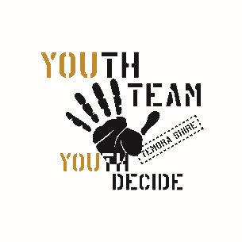
2023 Youth Team Membership Form
Youth Name:______________________________________
The Temora Youth Team are a bunch of crazy, cool kids. Everyone is welcome regardless of race, age, gender, sexuality or ability. It is a safe place where you can develop a sense of identity, self-worth, confidence, belonging, and achievement. We are one big family.

Youth Code:
1. Come with a positive attitude
2. Be respectful – in your language, gestures and behaviour
3. Refrain from inappropriate rough-housing
4. Use equipment safely and responsibly
5. Keep area tidy
6. Accept the directions of supervisors
7. This area is a drug and alcohol free zone + judgement free zone

Youth Teams: (Please tick)
 Hospitality- Tuesday
- Hospitality- Wednesday
- Culture and Performing Arts (Drama)
- Gaming
- Environmental (Green Team)
- Y Jam
Would you like to be added to the Team Facebook Messenger group? Y/ N
Facebook Name:
Address: _____________________________________________________________
Date of Birth: ______________________
Home phone: _______________________
Child’s Mobile: ___________________________
Parent/Guardian Email Address: _____________________________________________
Emergency Contact Person/s: ________________________________________________
Emergency Contact Phone Numbers: ____________________________________________
Additional information we may find helpful:
Example: Any food allergies, medical conditions….
________________________________________________________________________________________________________________________________________
I ____________________________________ have read and understood the Youth Code. I have looked over each rule carefully with my parent/guardian. I understand the rules are set forth to make sure that Platform Y is a safe and enjoyable environment for everyone, including myself. I agree to abide by all the rules whilst representing the Youth Team at Platform Y or any other venue. I understand that my failure to follow the above rules may result in my suspension from the Youth Team and all activities.
______________________________ ______________________________
Youth Signature + Date Parent Signature + Date
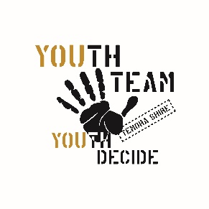
2023 Youth Team
Permission to Photograph
Dear Parent/ Carer.
There may be times at Platform Y when your child will be photographed whilst participating in activities. These photographs are used for the Temora Youth Facebook page, Temora Shire Council media platforms and the local media. This allows us to promote the fantastic programs on offer for Temora Youth, as well as highlight the success of our young people. Children will be referred to by their first name only.
We require parental permission to publish any photographs of your child/ren. Please complete the consent form below and return it to Platform Y.
Permission can be withdrawn at any time by notifying me in writing.
Please feel free to call me should you have any further questions.
We look forward to publicising the great work of our young people to the wider Temora Community.
With thanks,
Sheree Elwin
Youth Development Officer
Temora Shire Council
Phone: 0447 542451
_______________________________________________________________________
PERMISSION TO PHOTOGRAPH

Name of child/ren: ________________________________________________________

I give permission for photographs of my child/ren to be published on Temora Youth Facebook page, Temora Shire Council media platforms and the local media. I am aware that my child/ren’s first name may also accompany the photograph.
Parent/ carer name: ______________________________________
Parent/ carer signature: ___________________________________ Date: ____________

