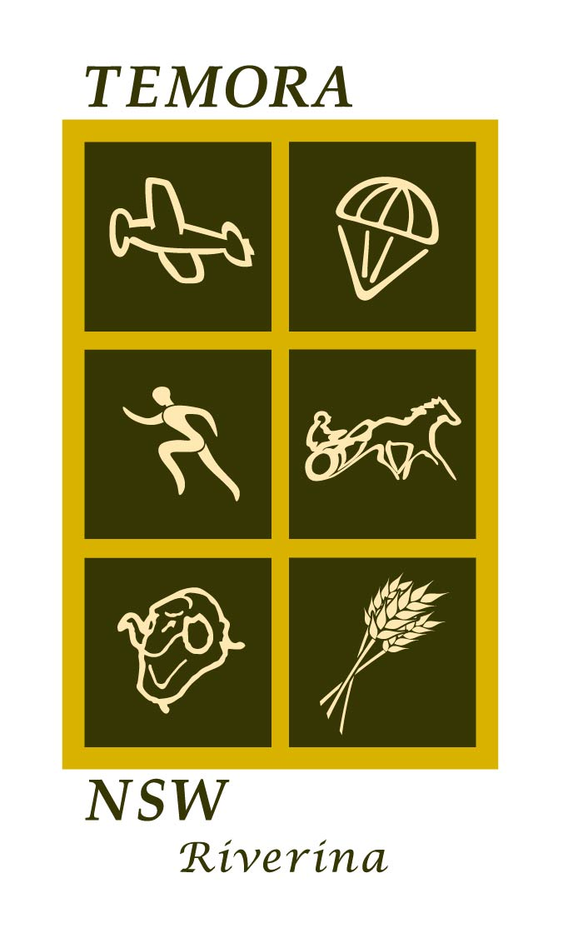
Form – Application to use Council facilities

TEMORA SHIRE COUNCIL

We, the ______
(Name of organisation/school)

of ______
(Address of organisation)

and incorporated under ______
(Type of Statute, eg. NSW)

wish to make an application to use ______
(Council’s facility)

The event that we are conducting is: ___________________________

______

We apply to use the facility on the following days and times, under the direction of our organisation for:-

*Day Time

_______ ___________

______ __________

______ ___________

______ ___________

______ ___________

___________________________

* (or nominate block period)

____________________________to _________________________

_____________________________to _________________________

____________________________to _________________________

Form – Application to use Council facilities

CONDITIONS OF USE

We agree to the following conditions being met and fulfilled by our organisation:-

- The organisation must present to Council evidence of a current public liability policy with a minimum cover of $20 million (attach photocopy).
2. Organisations are to make inspections of the facilities prior to and following event/meeting.
- Organisations are to report any hazard or defect noted during those inspections.
- No unauthorised vehicles are to be driven on the facilities.
- Facilities are to be left in a clean and tidy condition.
- Amenities are to be left in a clean and tidy condition.
- Council’s decision will be final on the allocation of facilities.

NB: Please keep attached copy of completed form for your records.

_____ _____________
(Signature of Applicant) (Position)

_____________________
(Date)

